Introduction:

What is an Operating System?

A Computer System comprises of the hardware, the operating system, the application programs, and the users.

User
1

User
2

User
3

User
n

Compiler assembler text editor database system

System and application programs

Operating system

Computer hardware

An Operating System is a program that manages the computer hardware (CPU, Memory and I/O devices), software ( System and Application Programs such as word processors, spreadsheets, compilers, and web browsers), and data. The O.S. provides the means for the proper use of these resources (by the users) in the operation of the computer system.
O.S. can be explored from two viewpoints: the user and the system.

User View: O.S. is designed mostly for ease of use for the user of stand alone machine, terminal connected to mainframe or minicomputer. Other users share resources and may exchange information from the same computer (server—file, compute or print server) through other terminals or workstations, connected in the network. Therefore, their operating system is designed to compromise between individual usability and resource utilization. Embedded computers have little or no user view and their operating systems are designed to run without user intervention.

System View: O.S. can be viewed as a resource allocator to solve the hardware and software problems such as CPU time, memory space file-storage space, I/O devices etc.
O.S. acts as the manager of these resources and decide how to allocate them to specific programs and users so that it can operate the computer system efficiently and fairly.
O.S. is especially concerned with the operation and control of I/O devices, a control program manages the execution of user programs to prevent errors and improper use of the computer.
A more common definition is that the O.S. is the one program running at all times on the computer( called the kernel ), with all else being application programs.

System Goals: Efficient operation of the computer system with the convenience for the user( many graphic user interfaces-GUIs were added).

Types of Operating System: Evolution of OS

1. Mainframe Systems
Mainframe Computer Systems were the first computers used to tackle many commercial and scientific applications
There are two types of Mainframe Systems, one is called as batch systems, where the computer runs one and only one application and other is called as time-shared systems, which allow for user interaction with the computer system.

Batch Systems

Computers in the olden days were run from the console. The common input devices were card readers and tape drives. The common output devices were line printers, tape drives, and card punches. The user did not interact directly with the computer systems. Rather, the user prepared a job which consisted of the program, the data, and some control information about the nature of the job(control cards) and submitted it to the computer operator. The job was usually in the form of punch cards. At some later time( after minutes, hours, or days), the output appeared. The output consisted of the result of the program, as well as a dump of the final memory and register contents for debugging.
The major task of the operating system (always resident in memory) was to transfer control automatically from one job to the next.
To speed up processing, operators batched together jobs with similar needs and ran through the computer as a group. Thus, the programmers would leave their programs with the operator who would sort programs into batches with similar requirements and, would run each batch whenever computer became available.. The introduction of the disk technology allowed the O.S. to keep all jobs on a disk, rather than in a serial card reader. O.S. could perform job scheduling, to use resources and perform tasks efficiently.

1.2 Multiprogrammed Systems

The O.S. keeps several jobs in memory simultaneously (see figure).

Operating system

Job1

Job2

Job3

Job4
0

512K

The O.S. picks and begins to execute one of the jobs in the memory. Eventually, the job may have to wait for some task, such as an I/O operation, to complete. In a Non-Multiprogrammed system, the CPU would sit idle. In a multiprogramming system, the O.S. simply switches to, and executes, another job. When that job needs to wait, the CPU is switched to another job, and so on. Eventually, the first job finishes waiting and gets the CPU back. As long as at least one job needs to execute, the CPU is never idle.
All the jobs that enter the system are kept in the job pool. This pool consists of all processes residing on disk awaiting allocation of main memory. If several jobs are ready to be brought into memory, and if there is not enough room for all of them, then the system must choose among them. Making this decision is CPU scheduling. Finally, multiple jobs running concurrently require that their ability to affect one another be limited in all phases of the O.S., including process scheduling, disk storage, and memory management.

1.3. Time-Sharing Systems

Time Sharing( or multitasking) is a logical extension of multiprogramming. The CPU executes multiple jobs by switching among them, but the switches occur so frequently that the users can interact with each program while it is running.
An interactive (or hands-on) computer system provides direct communication between the user and the system, through a keyboard or a mouse with a short response time.
As the system switches rapidly from one user to the next, each user is given the impression that the entire computer system is dedicated to her use, even though it is being shared among many users.
Each user has at least one separate program in memory. A program is loaded into memory and executing is commonly referred to as a process. When a process executes, it typically executes for only a short time before it either finishes or needs to perform I/O for the user to display output or the input through the keyboard, mouse or any other device. This may lead to slow down the speed and therefore, instead of CPU sitting idle it may rapidly switch the CPU to the program of some other user.
Several jobs must be kept simultaneously in memory, so the system must have memory management and protection. To obtain a reasonable response time, jobs may have to be swapped in and out of the main memory to the disk that now serves as a backing store for main memory. A common method for achieving this goal is virtual memory, which is a technique that allows the execution of a job that may not be completely in memory. The main advantage of the virtual-memory scheme is that programs can be larger than physical memory. Further, it abstracts main memory into a large, uniform array of storage, separating logical memory as viewed by the user from physical memory. This arrangement frees programmers from concern over memory-storage limitations.
Time-sharing system must also provide a file system. The file system resides on a collection of disks; hence disk management must be provided. It must also provide a mechanism for concurrent execution with sophisticated CPU-scheduling scheme , job synchronization and communication, and it may ensure that jobs do not stuck in a deadlock, forever waiting for one another.

2. Desktop Systems

PC operating System were neither multi-user nor multitasking. The goals of these Operating Systems were to maximize CPU and peripheral utilization, the systems opt for maximizing user convenience and responsiveness. The user interface was given more importance. Initially there was Command Based Interface like DOS ,but users need to know all the commands to interact with operating system. With Windows , the concept of Graphical user Interface came in to existence which made usage of computers easier for even layman.The various operating systems are MS-DOS,OS/2 , MS. Windows and the Apple Macintosh , Linux and Unix .

3. Multiprocessor systems

Multiprocessor systems also known as parallel systems or tightly coupled systems.
Multiprocessor Systems have more than one processor in close communication, sharing the computer bus, the clock, and sometimes memory and peripheral devices. The Multiprocessor systems have three main advantages.
- Increased throughput. By increasing the number of processors, get more work done in less time. When multi processors cooperate on a task, a certain amount of overhead is incurred in keeping all the parts working correctly. This overhead, plus contention for shared resources, lowers the expected gain from additional processors.
- Economy of scale. More money is saved because they can share peripherals, mass storage, and power supplies. If several programs operate on the same set of data, it is cheaper to store those data on one disk and to have all the processors share them, than to have many computers with local disks and many copies of the data.
- Increased reliability. If the functions are distributed properly among several processors, then the failure of one processor will not halt the system, only slow it down. Continued operation in the presence of failures requires a mechanism to allow the failure to be detected, diagnosed, and if possible, corrected, called as graceful degradation or fault tolerant. The most common multiple-processor systems now use symmetric multiprocessing (SMP), in which each processor runs an identical copy of the O.S.. and these copies communicate with one another as needed. Some systems use asymmetric multiprocessing (master-slave relationship), in which each processor is assigned a specific task. A master processor controls the system; the other processors either look to the master for instruction or have predefined tasks. The master processor schedules and allocate work to the slave processors. SMP means that all processors are peers; no master-slave relationships exist between processors as shown in the figure.
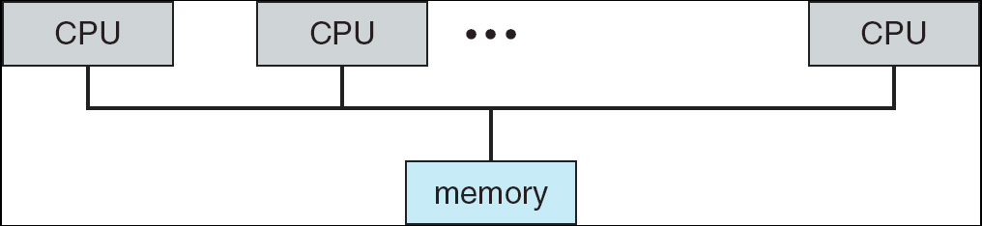

A multiprocessor system of this form will allow processes and resources-such
as memory-to be shared dynamically among the various processors. All modern O.S. such as Windows NT, Solaris, Digital UNIX, OS/2, and Linux-now provide support for SMP.
The difference between symmetric and asymmetric multiprocessing may be the result of either hardware or software. Special hardware can differentiate the multiprocessors , or the software can be written to allow only one master and multiple slaves. E.g. Sun’s operating system SunOS Ver.4 provides asymmetric multiprocessing whereas Ver.5 (Solaris 2) is symmetric on the same hardware.

4. Distributed Systems

a). Computer systems working under a network is called as distributed system which depends upon the protocols used, the distances between nodes, and the transport media.
TCP/IP is the most common network protocol( mostly used in Windows, UNIX and Linux O.S.), although ATM and other protocols are in widespread use.
Networks are typecast based on the distances between their nodes. A local-area network (LAN), exists within a room, a floor, or a building. A metropolitan-area network (MAN), could link building within a city. Blue Tooth devices communicate over a short distance of several feet, creating a small-area network A wide-area network (WAN), usually exists between buildings, cities, or countries. A global company may have a WAN to connect its offices, worldwide.
Networks vary by their performance and reliability upon the media to carry . They include copper wires, fiber strands, and wireless transmissions between satellites, microwave dishes and radios. Computing devices connected to cellular phones can be used for a network. Even very short-range infrared communication can be used for networking.
b). Client-Server Systems
In this system a centralized computer systems called as Server Systems are connected to the number of workstations called as client systems which request the services to the server systems as shown in the figure..

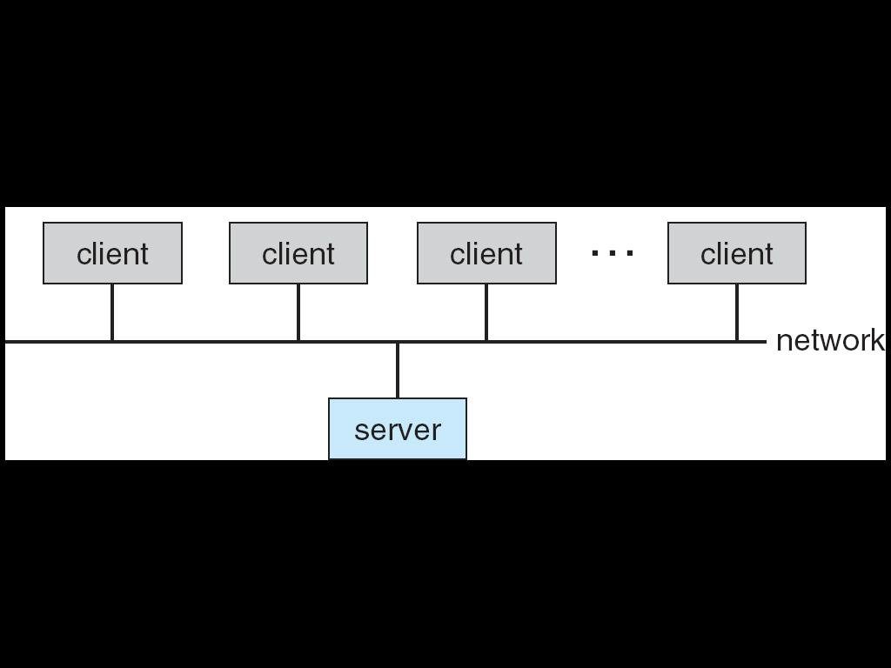

Server systems can be broadly categorized as computer servers and file servers.
- Computer-server systems provide an interface to which clients can send requests to perform an action, in response to which they execute the action and send back results to the client.
- File-server systems provide a file-system interface where clients can create, update, read, and delete files.

c). Peer-to-Peer Systems
In this type of computer system each PC connected in the network acts as a client as well as a server. There is no separate server as such. Each processor has its own local memory. The processors communicate with one another through various communication lines, such as high-speed buses or telephone lines. These systems are usually referred to as loosely coupled systems (or distributed systems).
A network operating system is an operating system that provides features such as file sharing across the network, and that includes a communication scheme that allows different processes on different computers to exchange messages .

5. Clustered Systems

Clustered systems differ from parallel systems, however, in that they are composed of two or more individual systems coupled together. The generally accepted definition is that clustered computers share storage and are closely linked via LAN networking.
Clustering is usually performed to provide high availability. A layer of cluster software runs on the cluster nodes. Each node can monitor one or more of the others(over the LAN). If the monitored machine fails, the monitoring machine can take ownership of its storage, and restart the application(s) that were running on the failed machine. The failed machine can remain down, but the users and clients of the application would only see a brief interruption of the service.
In asymmetric clustering, one machine is in hot standby mode while the other is running the applications. The hot standby host (machine) does nothing but monitor the active server. If that server fails, the hot standby host becomes the active server. In symmetric mode, two or more hosts are running applications, and they are monitoring each other. It does require that more than one application be available to run..
Other forms of clusters include parallel clusters and clustering over a WAN. Parallel clusters allow multiple hosts to access the same data on the shared storage and are usually accomplished by special version of software and special releases of applications. For example, Oracle Parallel Server is a version of Oracle’s database that has been designed to run parallel clusters.
Most clusters do not allow shared access to data on the disk. For this, distributed file systems must provide access control and locking to the files to ensure no conflicting operations occur. This type of services is commonly known as a distributed lock manager (DLM).
Storage-area networks (SANs) are the feature development of the clustered systems includes the multiple hosts to multiple storage units.

6. Real-Time Systems

A real-time system is used when rigid time requirements have been placed on the operation of a processor or the flow of data; thus, it is often used as a control device in a dedicated application. Sensors bring data to the computer which analyzes and possibly adjust controls to modify the sensor inputs. Some scientific experiments, medical imaging systems, industrial control systems, certain display systems, automobile-engine, fuel injection systems, home appliance controllers and weapon systems are real-time systems.
In a real-time system Processing must be done within the defined constraints, or the system will fail.
Real time systems are available in two flavors, a hard real-time system and a soft real-time system. In a hard real-time system the critical tasks be completed on time Therefore, in this system their should not be any delay in retrieving the data. Secondary storage of any sort is usually limited or missing, with data instead being stored in short term memory, read only memory (ROM). Virtual memory is almost never found in real-time systems. The operating system kernel delays need to be bounded.A real time task cannot be kept waiting indefinitely for the kernel to run it.
In a soft real-time system, a critical real-time task gets priority over other tasks, and retains that priority until it completes . Soft real-time systems have more limited utility than hard real-time but they are useful for multimedia, virtual reality, and advanced scientific projectssuch as undersea exploration and planetary rovers.These systems need advanced operating systems such as UNIX. Windows-2000, windows XP etc.

Components of OS

1. Process Management: A process can be thought of as a program in execution. A time-shared user program such as a compiler is a process. A word- processing program being run by an individual user on a PC is a process. A system task, such as sending output to a printer is also a process.
A process needs certain resources, which includes CPU time, memory, files and I/O devices to accomplish its task. These resources are either given to the process when it is created, or allocated to it while it is running. Various initialization data (input) may be passed along with the physical and logical resources that are obtain by the process creation. E.g. a process whose function is to display the status of a file on the screen of a terminal. The process will be given as an input the name of a file, and will execute the appropriate instructions and system calls to obtain and display on the terminal the desired information. After the termination of the process, the O.S. will reclaim any reusable resources.
Program by itself is not a process; a program is a passive entity, such as the contents of a file stored on disk, whereas a process is an active entity, with a program counter specifying the next instruction to execute. The CPU executes one instruction of the process after another sequentially, until the process completes. At any time, at most one instruction is executed on behalf of the process. Thus, if two processes may be associated with the same program, they are however considered two separate execution sequences.
A process is the unit of work in a system. Such a system consists of a collection of processes, some of which are Operating System processes (those that execute system code) and the rest of which are user processes (those that execute user code). All these processes can potentially execute concurrently, by multiplexing the CPU among them.
The O.S. is responsible for the following activities in connection with process management:
- Creating and deleting both user and system processes.
- Suspending and resuming processes.
- Providing mechanisms for process synchronization.
- Providing mechanisms for deadlock handling.
2. Main memory Management: Main Memory is the central part of operation of the modern computer systems. Main memory is a large array of words or bytes having Megabytes or Gigabyte size. Each word or byte has its own address. Main memory is a repository of quickly accessible data shared by the CPU and I/O devices. The central processor reads instructions from main memory during the instruction-fetch cycle, and it both reads and writes data from main memory during the data-fetch cycle. The I/O operations implemented via DMA also read and write data in main memory. The main memory is the only large storage device that the CPU is able to address and access directly.E.g. The CPU 6o process data from disk, those data must first be transferred to main memory by CPU-generated I/O calls. Equivalently, instructions must be in memory for the CPU to execute them.
For a program to be executed, it must be mapped to absolute addresses and loaded into memory. As the program executes, it accesses program instructions and data from memory by generating these absolute addresses. Eventually, the program terminates, its memory space is declared available, and the next program can be loaded and executed.
Several programs must be in memory to improve the utilization of CPU and to increase the computers speed in response to its users.
There are so many memory management schemes available depending upon the design of the hardware and the on the particular situation.
The O.S. is responsible for the following activities in connection with memory management:
- Keeping track of which parts of memory are currently being used and by whom.
- Deciding which processes are to be loaded into memory when memory space becomes available.
- Allocating and deallocating memory space as needed..

3. Secondary storage Management: Main memory, or primary storage, is too small to accommodate all data and programs, and because the data that it holds are lost when power is lost, the computer system must provide secondary storage to back up main memory. Most modern computer systems use disks as the principal on-line storage medium, for both programs ( including compilers, assemblers, sort routines, editors, and formatters) and data. Disk acts as both source as well as destination of the process and therefore, there must be a proper management of the disk storage.
The O.S. is responsible for the following activities in connection with disk management:
- Free-space management.
- Storage allocation.
- Disk scheduling.
The entire speed of operation of the computer system depends upon the speeds of disk subsystems and of the algorithms that manipulate that subsystem.

4. File Management: A file is a collection of related information defined by its creator. Commonly, files represent programs (both source and object forms) and data. Data files may be numeric, alphabetic, or alphanumeric. Files may be free-form (e.g. text files) or may be formatted rigidly (e.g. fixed fields). A file consists of a sequence of bits, bytes, lines, or records whose meaning defined by their creators. The operating system maps files onto physical media (mass storage media), and accesses these files via the storage devices(Magnetic tape, magnetic disk, and optical disk). Also, files are normally, organized into directories to ease their use. When multiple users have access to files, we may want to control by whom and in what ways (e.g., read, write, append) files may be accessed.
The O.S. is responsible for the following activities in connection with file management:
- Creating and deleting files.
- Creating and deleting directories.
- Supporting primitives for manipulating files and directories.
- Mapping files onto secondary storage.
- Backing up files on stable (nonvolatile) storage media.

5. I/O-System Management: One of the purposes of an O.S. is to hide the hardware devices from the user e.g. in UNIX I/O devices are hidden from the operating system. Devices itself are considered to be files for O.S. Only the device drivers knows the peculiarities of the specific device to which is assigned. The I/O subsystem consists of
- A memory-management component that includes buffering, caching, and spooling.
- A general device-driver interface.
- Drivers for specific hardware devices.

Operating System Services
The Operating –System Services are provided for the convenience of the programmer, to make the programming task easier.
One set of operating-system services provides functions that are helpful to the user:
User interface - Almost all operating systems have a user interface (UI)
Varies between Command-Line (CLI), Graphics User Interface (GUI).

These services differ from one operating system to another but they have some common classes as follows:
- Program execution: The system must be able to load a program into memory and to run that program. The program must be able to end its execution, either normally or abnormally (indicating error).
- I/O operation: I/O may involve a file or an I/O device. Special functions may be desired (such as to rewind a tape drive, or to blank a CRT screen). I/O devices are controlled by O.S.
- File-system manipulation: File system program reads, writes, creates and deletes files by name.
- Communications: In many circumstances, one process needs to exchange information with another process. Communication may be implemented via shared memory, or by the technique of message passing, in which packets of information are moved between processes by the O.S.
- Error detection: Errors may occur in the CPU and memory hardware (such as a memory error or a power failure), in I/O devices (such as a parity error on tape, a connection failure on a network, or lack of paper in the printer), and in the user program(such as an arithmetic overflow, an attempt to access an illegal memory location, or too-great use of CPU time)O.S should take an appropriate action on these types of errors to correct .
- Resource allocation: When multiple users are logged on the system or multiple jobs are running at the same time, resources such as CPU cycles, main memory, and file storage etc must be allocated to each of them. O.S. have CPU-scheduling routines that take into account the speed of the CPU, the jobs that must be executed, the number of registers available, and other factors. There are routines for tape drives, plotters, modems, and other peripheral devices .
- Accounting: To keep track of which users use how many and which kinds of computer resources. This record keeping may be used for accounting(so that users can be billed)or simply for accumulating usage statistics.
- Protection: When several disjointed processes execute concurrently, it should not be possible for one process to interfere with the others, or with the O.S. itself. Security of the system from outsiders is also important and therefore user have to authenticate himself to the system, usually by means of a password, to be allowed access to the resources and also for the external I/O devices, including modems and network adapters.

Command Interpreter: Is the interface between user and OS. Some O.S. includes the command interpreter in the kernel. Other O.S. , such as MS-DOS and UNIX, treat the command interpreter as a special program that is running when a job is initiated, or when a user first logs on(on time-sharing systems). This program is sometimes called the control-card interpreter or the command-line interpreter, and is often known as the shell. Its function is simple: To get the next command statement and execute it. The command statements themselves deal with process creation and management, I/O handling, secondary storage management, main-memory management, file –system access, protection, and networking. The MS-DOS and UNIX shells operate in this way.

System calls
System calls provide the interface between a process and the operating system. These calls are generally available as assembly-language instructions.
Certain systems allow system calls to be made directly from a high-level language program, in which case the calls normally resemble predefined function or subroutine calls.
Several languages-such as C,C++, and Perl-have been defined to replace assembly language for system programming. These languages allow system calls to be made directly. E.g., UNIX system calls may be invoked directly from a C or C++ program. System calls for modern Microsoft Windows platforms are part of the Win32 application programmer interface(API), which is available for use by all the compilers written for Microsoft Windows. Three most common APIs are Win32 API for Windows, POSIX API for POSIX-based systems (including virtually all versions of UNIX, Linux, and Mac OS X), and Java API for the Java virtual machine (JVM)

Example of System Calls:
System call sequence to copy the contents of one file to another file

System calls occur in different ways, depending upon the computer in use. For example, to get input, we may need to specify the file or device to use as the source, and the address and length of the memory buffer into which the input should be read. .Of course, the device or file and length may be implicit in the call.
Three general methods are used to pass parameters to the operating system.
1. Using registers-The simplest approach is to pass parameters in registers.
2. Block of memory-In some cases, however, there may be more parameters than registers. In these cases, parameters are generally stored in a block or table in memory, and the address of the block is passed as a parameter in a register as shown in the figure. This is the approach taken by Linux

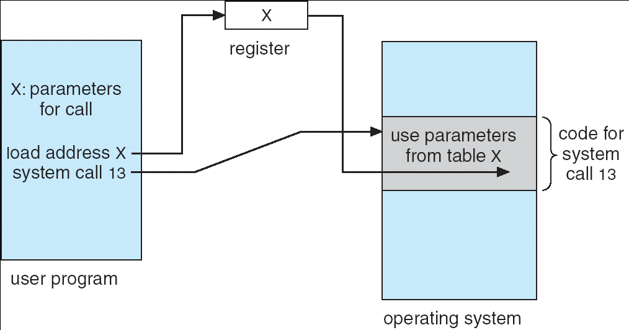

3. Using a common stack structure-Parameters can also be placed, or pushed, onto the stack by the program, and popped off the stack by the operating system.

System calls can be grouped roughly into five major categories: Process control, file management, device management, information maintenance and communications.
- Process Control – The system calls involved in process control come under this category.
  - End, abort- to terminate a process normally or abnormally
  - Load, execute-to load another process and let it execute
  - Create process, terminate process-to create or terminate a child process.
  - Get process attributes, set process attributes-to get and set attributes of the child processes.
  - Wait for time-to wait for a specified time for the child process to complete.
  - Wait event, signal event- Wait event system call to wait for the child process till an event occurs and the child process has to inform the parent process the occurrence of the event with a Signal event system call
  - Allocate and free memory-to allocate and free memory for the processes.
- File management-The system calls involved in file management come under this category.
  - Create, delete file-to create or delete a file
  - Open, close-to open or close a file
  - Read, write, reposition-to read ,write or reposition the file pointer within the file
  - Get file attributes, set file attributes-to get or set file attributes.
- Device management- The system calls involved in device management come under this category.

  - Request device, release device-Every process should request for a required device by making a request device system call and similarly after using the device should release the device by making a release device system call.
  - Read, write, reposition-to read,write or reposition the device head
  - Get device attributes, set device attributes-to get or set the device attributes
  - Logically attach or detach devices-to logically attach or detach the device from the process.
- Information maintenance The system calls involved in maintaining system information come under this category.
  - Get time or date, set time or date
  - Get system data, set system data
  - Get process, file, or device attributes
  - Set process, file, or device attributes
- Communications
Two types of process communication exist namely Shared memory method and Message passing method.
Message passing method is entirely controlled by operating system kernel hence involve a large no of system calls like
  - Create, delete communication connection
  - Send, receive messages
  - Transfer status information
  - Attach or detach remote devices
In shared memory method the kernel performs the initialization of the communication. Then the process take care of the communication with their codes. Thus a memory map system call occurs to start with the communication.

System programs: Different categories of system programs.

System programs provide a convenient environment for program development and execution. Some of them are simply user interfaces to system calls; others are considerably more complex. They are divided into the following categories:
- File management: These programs create, delete, copy, rename, print, dump, list, and generally manipulate files and directories.
- Status information: Some programs simply ask the system for the date, time, amount of available memory or disk space, number of users, or similar status information. That information is then formatted, and is printed to the terminal or other output device or file.
- File modification: Several text editors may be available to create and modify the content of files stored on disk or tape.
- Programming-language support: Compilers, assemblers, and interpreters for programming languages (such as C, C++, Java, Visual Basic and perl) are often provided to the user with the O.S.
- Program loading and execution: Once a program is assembled or compiled, it must be loaded into memory to be executed the system may provide absolute loaders, relocatable loaders, linkage editors, and overlay loaders. Debugging systems for either high-level languages or machine languages are needed also.
- Communications: These programs provide the mechanism for creating virtual connections among processes, users, and different computer systems. They allow users to send messages to one another’s screens, to browse web pages, to send e-mail, to log in remotely, or to transfer files from one machine to another.
- System utilities or application programs: Programs include web browsers, word processors and text formatters, spreadsheets, database systems, compiler compilers, plotting and statical-analysis packages, and games.
- Command interpreter: Main function of which is to get and execute the next user-specified command.

OS structure:Simple structure, Layered approach, Kernel based approach

Simple structure

The operating system is created without a well defined structure.Frequently ,such operating system started as small,simple and limited systems and then grew beyond their original scope.
MS-DOS ia an example of such a system( see figure)
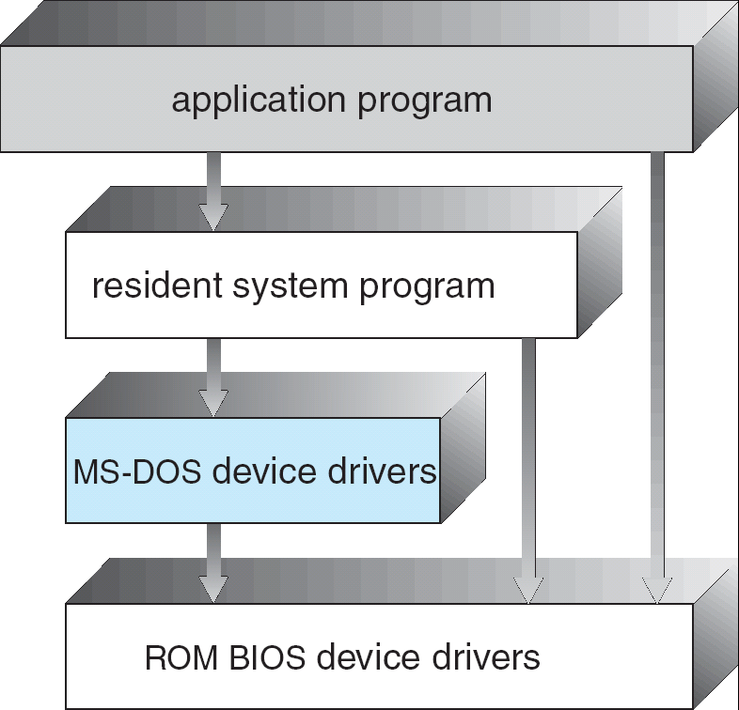

MS-DOS Layer Structure

We can view the traditional UNIX operating system as shown in the figure:
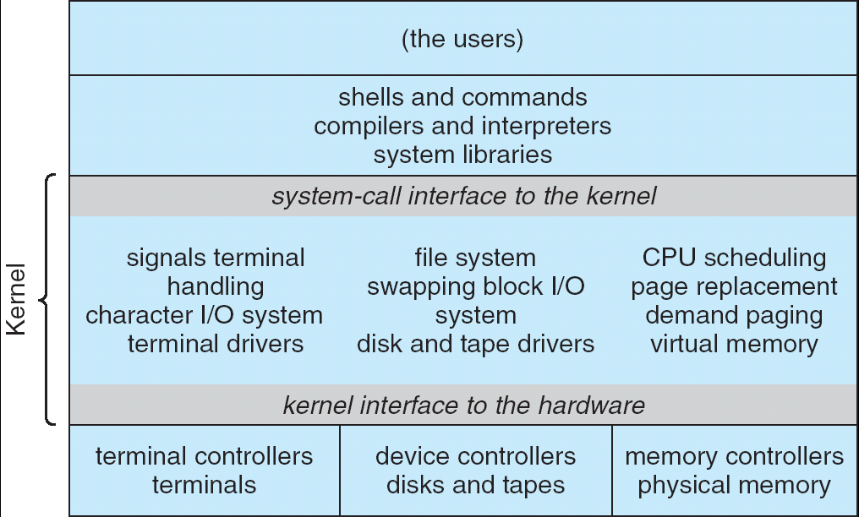

UNIX System Structure

Layered approach
The operating system is divided into a number of layers (levels), each built on top of lower layers. The bottom layer (layer 0), is the hardware; the highest (layer N) is the user interface.
With modularity, layers are selected such that each uses functions (operations) and services of only lower-level layers. A layer M will have a structure as shown below

The main advantage of this approach is modularity. The layers are selected such that each uses functions and services of only lower level layers. This approach simplifies debugging and system verification. The first layer can be debugged without any concerns for the rest of the system ,because by definition,it uses only the basic hardware to implement its functions. Once the first layer is debugged, its correct functioning can be assumed while the second layer is worked on ,and so on. If an error is found during debugging of a particular layer,we know that the error must be on that layer,because the layer below it are already debugged. Thus the design and implementation is simplified when the system is broken down into layers.
Each layer is implemented with only those operations provided by lower-level layers. A layer does not need to know how these operations are implemented; it needs to know only what these operations do. Hence, each layer hides the existence of certain data structures, operations, and hardware from higher-level layers. The major difficulty with the layered approach involves the careful definition of the layers.
A final problem with the layered implementations is that they are less efficient than other type e.g to when a user program executes an I/O operation, it has to go through the system call layer, memory management layer CPU scheduling layer and then pass to the hardware and therefore at each layer the parameters may be modified, data may need to be passed and each layer adds overheads to the system call and thus take longer time than does one on a non layered system.

Kernel based approach-Microkernels:
At Carnegie Mellon University developed an operating system called Mach that modularizes the kernel using the microkernel approach. In this method the operating system is structured by removing all nonessential components from kernel, and implementing them as system and user level programs, resulting a smaller kernel In general, however, microkernels typically provide minimal process and memory management, in addition to a communication facility.
The main function of the microkernel is to provide a communication(by message passing) facility between the client program and the various services that are also running isn user space.
The benefits of the microkernel approach include the ease of extending the O.S. All the new services are added to user space and consequently do not require modification of the kernel. When the kernel does have to be modified, the changes tend to be fewer, because the microkernel is a smaller kernel. The resulting O.S. is easier to port from one hardware design to another. The microkernel also provides more security and reliability, since most services are running as user- rather than kernel-process. If a service fails, the rest of O.S. remains untouched. Tru64 UNIX(formerly Digital UNIX), Apple MacOSX Server O.S. are based on the Mach kernel(michrokernel). QNX is a real-time O.S.uses michrokernel, providing services for message passing and process scheduling. Window NT including Win32, OS/2 and POSIX use michrokernel approach.

System Design and Implementation

OS design issues:
1. Design Goals: The first problem in designating a system is to define the goals and specifications of the system. The design of the system will be affected by the choice of hardware and type of system: batch, time shared, single user, multi-user, distributed, real time, or general purpose.
The requirements can be divided into two basic groups: user goals and system goals.
User goals: The system should be convenient and easy to use, easy to learn, reliable, safe and fast.
System goals: the operating system should be asy to design, implement, and maintain; it should be flexible, reliable, error free, and efficient.
2. Mechanisms and Policies: The specification and design of an operating system is a highly creative task and general software engineering principles do exist that are especially applicable to operating systems. One important principle is the separation of policy from mechanism. Mechanisms determine how to do something: policies determine what will be done. Policies are likely to change across places or over time. In the worst case, each change in policy would require a change in the underlying mechanism. A general mechanism would be more desirable. A change in policy would then require redefinition of only certain parameters of the system. For instance, if, in one computer system, a policy decision is made that I/O-intensive programs should have priority over CPU-intensive ones, then the opposite policy could be instituted easily on some other computer system if the mechanism were properly separated and were policy independent.
Microkernel-based operating systems take separation of mechanism and policy by implementing a basic set of primitive building blocks, via user created kernel modules, or via user programs themselves. These blocks are almost policy free. Policy decisions must be made for all resource-allocation and scheduling problems.
3. Implementation: The operating system must be written in high level languages such as C o C++, because it is far easier to port-to move to some other hardware. e.g. MS-DOS was written in Intel 8088 assembly language and consequently, it is available on only the Intel family of CPUs. The UNIX operating system, on the other hand, which is written mostly in C, is available on number of different CPUs, including Intel80X86, Pentium, Motorola 680X0, ULTRA SPARC, Compaq Alpha, and MIPS RX000..
Major performance improvements in operating systems are more likely to be the result of better data structures and algorithms in high-level languages than the assembly language codes. After the system is written and working correctly, bottleneck routines can be identified and replaced with assembly-language equivalents.
Process Management:

What is a Process?
A process can be thought of as a program in execution. A process is more than the program code, which is sometimes known as the text section. It also includes the current activity, as represented by the value of the program counter and the contents of the processor’s registers. In addition, a process generally includes the process stack, which contains temporary data(such as method parameters, return addresses, and local variables) , and a data section, which contains global variables. A process will need certain resources- such as CPU time, memory, files, and I/O devices- to accomplish its task. These resources are allocated to the process either when it is created or while it is executing.
A program is a passive entity, such as the contents of a file stored on disk, whereas a process is an active entity, with a program counter specifying the next instruction to execute and a set of associated resources.
A process is the unit of work in most systems. Such a system consists of a collection of processes: Operating-system processes execute system code, and user processes execute user code. All these processes may execute concurrently.
Although traditionally a process contained only a single thread of control as it ran, most modern operating systems now support processes that have multiple threads.
The operating system is responsible for the following activities in connection with process and thread management: the creation and deletion of both user and system processes: the scheduling of processes; and provision of mechanisms for synchronization, communication, and deadlock handling for processes.

Process states: two state and five state model

Process State: As the process executes, it changes state. The state of a process is defined in part by the current activity of that process. Each process may be in one of the following states:
- New: The process is being created.
- Running: Instructions are being executed.
- Waiting: The process is waiting for some event to occur (such as an I/O completion or reception of a signal).
- Ready: The process is waiting to be assigned to a processor.
- Termination: The process has finished execution.
These state name are arbitrary but the states they represent are found on all systems, however, certain OS. more finely define process states.

TWO STATE PROCESS MODEL
Not
Running
Running

Dispatch
Pause
1. State Transition Diagram
Exit
Enter

Processor
Enter
Pause
Queue
Dispatch
Exit
1. Queuing Diagram

A process may be in one of 2 states not running and running Figure illustrates when OS creates a new process it inters that process into the system in the not running state. Thus the process exists and is waiting for an opportunity to execute. From time to time the currently running process will be interrupted and the dispatcher portion of the OS will select a new process to run. The former process moves from running state to not running state and one of the process moves to the running state. when a process is interrupted it is transferred to the queue of waiting processes alternatively if the process has completed or aborted, the process is discarded.

Five state model:

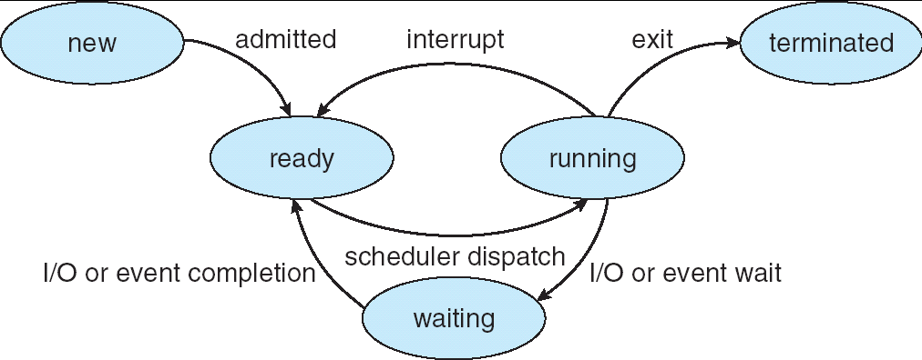

Only one process can be running on any processor at any instant, although many processes may be ready and waiting.
New
Ready
Running
Exit
Blocked
Time-out
Event Occurs
Event Wait
Admit
Dispatch
Release

The 5 states in the above diagram are as follows.
- RUNING = >
The process that is currently being executed.
- READY = >
Processes those are ready to execute when given the opportunity.
- BLOCKED = >
A process that cannot execute until some events occur.
- NEW = >
A process that has first been created but has not yet been admitted in the pool of executable processes.
- EXIT = >
A process that has been released from the pool of executable processes either because it is halted or aborted for some reasons.

A process exits the system in 2 stages.
- A process is terminated when it reaches a natural completion point

- When another process with appropriate authority causes the process to abort / terminate, moves the process to EXIT STATE.

HOW DOES THE OPERATING SYSTEM MANAGE THESE PROCESSES?

The ways of managing processes is quite complicated & put of are scope but knowing the concept is essential.

OPERATING SYSTEM CONTROL STRUCTURES

Process
Image

Memory
Processes
Files
Devices
Process n
Process 3
Process 1
Memory Tables
File Tables
I / O Tables
Process 2
Process
1
Process
n

Process

General Structure Of Operating System Control Tables

If the OS is to manage processes and resources it must have information about current status of each process and resource. The OS constructs and maintains tables of information about each entity that it is managing. Above figure shows 4 different types of tables maintained by OS =>memory, I/O, File and process.

- Memory tables are used to keep track of both main and secondary memory & reserved for use by the OS. The remainder is available for use by the processes. Processes are maintained on secondary memory by using some sort of virtual memory or by simple swapping mechanism. The memory table must include following information.

- The allocation of the main memory to processes.
- Allocation of secondary memory to processes.
- Any protection attributes e.g., some files is only read, nobody to write to it.
- Any information to manage to virtual memory.

- I/O tables are used by OS to manage the I/O device and channels of computer system. If and I/O operation is in process the OS needs to know the status of the input operation and the location in main memory being used as a course or destination of I/O transfer. I.e., buffer Address space.

- File Tables – provide information about the existence of files, their location on secondary memory, their current status and other attributes. This information may be maintained and used by a file management system.

- Finally OS must maintain process tables to manage processes. Above figures shows 4 distinct set of tables, it should be clear that these tables must be linked or cross referenced in some fashion memory. I/O and files are managed on behalf of processes so there must be direct or indirect reference to those resources in the process tables. OS must have the knowledge of the basic environment such as how much main memory exists, what the I/O devices are and so on. This is an issue of configuration, i.e., which process manages which resource.

INTERNAL STRUCTURE OF A PROCESS
A program under execution is called as a process. This explains that a process must consist of the following:
- A program or a set of program.
- Data to be used by the program defined by the user.
- Certain memory space used to keep track of procedure calls and the parameter passing between procedures, called as stack.
- Attributes of the process, which are stored in the PCB (Process Control Block).
From the above we need to pay more attention to the PCB.
PROCESS CONTROL BLOCK
In a sophisticated multiprogramming system a great deal of information about each
Process is required for process management & resides in a process control block also called as a task control block. A PCB is shown in the figure.
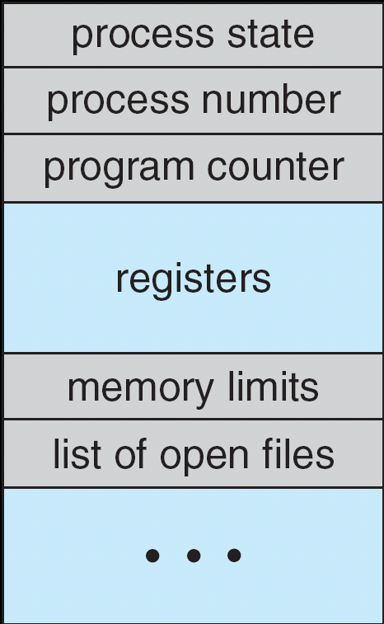
It contains many pieces of information associated with a specific process, including these:
- Process identification: With respect for Process identification each process is assigned a unique numeric identifier. Many of the other tables controlled by OS may use process identifiers to cross reference process tables. When processes are allowed to create another process, identifiers are used to indicate the parent and the descendent of each process. In addition to these process identifiers, the process may be assigned a user identifier that indicates the user who is responsible for the job.
- Process State: The state may be new, ready, running, waiting, halted, and so on.

- Program Counter: The counter indicates the address of the next instruction to be executed for this process.
- CPU registers: The registers vary in number and type, depending upon the computer architecture. They include accumulators, index registers, stack pointers, and general-purpose registers, plus any condition-code information. Along with the program counter, this state information must be saved when an interrupt occurs, to allow the process to be continued correctly afterward
- CPU-Scheduling information: This information includes a process priority, pointers to scheduling queues, and any other scheduling parameters.
- Memory-management information: This information may include such information as the value of the base and limit registers, the page tables, or the segment tables, depending on the memory system used by the OS.
- Accounting information: This information includes the amount of CPU and real time used, time limits, account numbers, job or process numbers, and so on.
- I/O status information: The information includes the list of I/O devices allocated to this process, a list of open files, and so on.

The PCB simply serves as the repository for any information that may vary from process to process.
The following diagram shows how the CPU switch from process to process by using PCB after the interrupt or system call.
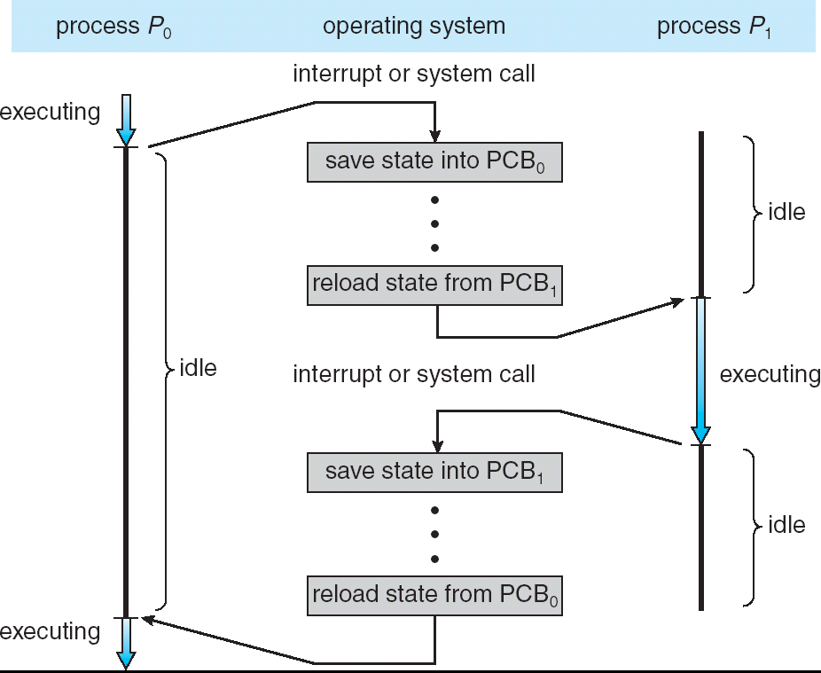

Operation on processes: Creation, Termination,
Cooperation among the processes.

PROCESS CREATION

A process may create several new processes, via a create-process system call, during the course of execution. The creating process is called a parent process, whereas the new processes are called the children of that process. Each of these new processes may in turn create other processes, forming a tree of processes as shown below.

root
Page daemon
swapper
init
User2
User1
User3
A tree of processes on a typical UNIX system

In general, a process will need certain resources(such as CPU time, memory, files, I/O devices) to accomplish its task. When the process creates a sub process, that sub process may be able to obtain its resources directly from the OS, or it may be controlled to a subset of the resources of the parent process. The parent may have to partition its resources among its children, or it may be able to share some resources(such as memory or files) among several of its children. Restricting a child process to a subset of the parent’s resources prevent any process from overloading the system by creating too many sub processes.
When a process is created it obtains along with the resources, initialization data (or input from the file, say F1) that may be passed along from the parent process to the child process. It may also get the name of the output device. New process may get two open files, F1 and the terminal device, and may just need to transfer the datum between the two.
When a process creates a new process, two possibilities exist in terms of execution:
- The parent continues to execute concurrently with its children.
- The parent waits until some or all of its children have terminated.
There are also two possibilities in terms of the address space of the new process:
- The child process is a duplicate of the parent process.
- the child process has a program loaded into it.
In UNIX, each process is identified by its process identifier (PID), which is a unique integer. A new process is created by the fork system call. The new process consists of a copy of the address space of the original process. which helps the parent process to communicate easily with its child process. Both processes(the parent & the child) continue execution at the instruction after the fork system call, with one difference: The return code for the fork system call is zero for the new(child) process, whereas the (nonzero) process identifier of the child is returned to the parent.
To understand the above possibilities, consider the following C program:

int main()
{
Pid_t pid;
/* fork another process */
pid = fork();
if (pid < 0) { /* error occurred */
fprintf(stderr, "Fork Failed");
exit(-1);
}
else if (pid == 0) { /* child process */
execlp("/bin/ls", "ls", NULL);
}
else { /* parent process */
/* parent will wait for the child to complete */
wait (NULL);
printf ("Child Complete");
exit(0);
}
}

The parent creates a child process using the fork system call. We now have two different processes running a copy of the same program The value of the pid for the child process is zero; that for the parent is an integer value greater than zero. The child process overlays its address space with the UNIX command /bin/ls (used to get a directory listing) using the execlp system call. The parent waits for the child process to complete with the wait system call. When the child process completes, the parent process resumes from the call to wait where it completes using the exit system call.

Process Termination
A process terminates when it finishes executing its final statement and asks the OS to delete it by using the exit system call. At that point, the process may return data(output) to its parent process (via the wait system all). All the resources of the process, including physical and virtual memory, open files, and I/O buffers are deallocated by the OS.
A process can cause the termination of another process via an appropriate system call such as abort . Usually, only the parent of the process that is to be terminated can invoke such a system call otherwise you can arbitrarily kill each other’s jobs.
A parent may terminate the execution of one of its children for the following reasons:
- The child has exceeded its usage of some of the resources that it has been allocated. This requires the parent to have a mechanism to inspect the state of its children.
- The task assigned to the child is no longer required.
- The parent is exiting, and the OS does not allow a child to continue if its parent terminates. On such systems, if a process terminates(either normally or abnormally), then all its children must also be terminated. This is referred to as Cascading Termination, and is normally initiated by the OS. In the case of UNIX, if the parent terminates, however, all its children have assigned as the new parent the init process. Thus, the children still have a parent to collect their status and execution statistics.

Cooperating Processes:
A process is independent if it cannot affect or be affected by the other processes executing in the system. On the other hand, a process is cooperating if it can affect or be affected by the other processes executing in the system. Process cooperation is required for the following reasons:
- Information sharing: Several users may be interested in the same piece of information (for instance, a shared file), we must provide an environment to allow concurrent access to these types of resources.
- Computation speedup: If we want a particular task to run faster, we must break it into subtasks, each of which will be executing in parallel with the others. Such a speedup can be achieved only if the computer has multiple processing elements (such as CPUs or I/O channels).
- Modularity: To construct the system in a modular fashion, dividing the system functions into separate processes or threads.
- Convenience: Individual user may have many tasks on which to work at one time. For instance, a user may be editing, printing, and compiling in parallel.
Concurrent execution of cooperating processes requires mechanism that allow processes to communicate with one another and to synchronize their actions.

Interprocess Communication: Direct & indirect communication, message passing, synchronization, buffering.

Interprocess Communication: The OS provides the means for cooperating processes to communicate with each other via an interprocess communication (IPC) facility.
IPC provides a mechanism to allow processes to communicate and to synchronize their actions without sharing the same address space. IPC is particularly useful in a distributed environment where the communicating processes may reside on different computers connected with a network e.g. chat program used on the world wide web.
IPC is best provided by a message-passing system, and the message systems can be defined in many ways.

Message-Passing System: Message system is to allow processes to communicate with one another without the need to resort to shared data. Services are provided as ordinary user processes operate outside the kernel. Communication among the user processes is accomplished through the passing of messages. An IPC facility provides at least two operations: send(message) and receive(message). Messages sent by a process can be of either fixed or variable size.
If processes P and Q want to communicate, they must send messages to and receive from each other; a communication link must exist between them. There are several methods for logical implementation of a link as follows:
- Direct or indirect communication.
- Symmetric or asymmetric communication.
- Automatic or explicit buffering.
- Send by copy or send by reference.
- Fixed-sized or variable-sized message.

Direct Communication: Each process that wants to communicate must explicitly name the recipient or sender of the communication. The send and receive primitives are defied as:
- send (P, message) – Send a message to process P.
- receive (Q, message) – Receive a message from process Q.
A communication link in this scheme has the following properties:
- A link is established automatically between every pair of processes that want to communicate. The processes need to know only each other’s identity to communicate.
- A link is associated with exactly two processes.
- Exactly one link exists between each pair of processes.
This scheme exhibits symmetry in addressing; that is, both the sender and the receiver processes must name the other to communicate. A variant of this scheme employs asymmetry in addressing. Only the sender names the recipient; the recipient is not required to name the sender. In this scheme, the send and receive primitives are as follows:
- send (P, message) – Send a message to process P.
- receive (id, message) – Receive a message from any process; the variable id is set to the name of the process with which communication has taken place.
The disadvantage in both schemes: Changing the name of a process may necessitate examining all other process definitions. All references to the old name must be found, so that they can be modified to the new name. This situation is not desirable from the viewpoint of separate compilation.

Indirect Communication: The messages are sent to and received from mailboxes, or ports. Each mailbox has a unique identification. Two processes can communicate only if they share a mailbox. The send and receive primitives are defined as follows:

- send (A, message) - Send a message to mailbox A.
- receive (A, message) – Receive a message from mailbox A.

In this scheme, a communication link has the following properties:

- A link is established between a pair of processes only if both members of the pair have a shared mailbox.
- A link may be associated with more than two processes.
- A number of different links may exist between each pair of communicating processes, with each link corresponding to one mailbox.
If processes P_{1,} P₂ and P₃ all share mailbox A. Process P₁ sends a message to A, while P₂ and P₃ each execute a receive from A. Which process will receive the message depends upon the one of the scheme that use choose as follows:

- Allow a link to be associated with at most two processes.
- Allow at most one process at a time to execute a receive operation.
- Allow the system to select arbitrarily which process will receive the message(that is either P₂ or P₃, but not both, will receive the message). The system may identify the receiver to the sender.
If the mailbox is owned by process(that is, the mailbox is part of the address space of the process), then we distinguish between the owner(who can only receive messages through this mailbox) and the user (who can only send messages to the mailbox). When a process that owns a mailbox terminates, the mailbox disappears. Any process that subsequently sends a message to this mailbox must be notified that the mailbox no longer exists.
On the other hand, a mailbox owned by the OS is independent and is not attached to any particular process. The OS then must provide a mechanism that allows a process to do the following:
- Create a new mailbox.
- Send and receive messages through the mailbox.
- Delete a mailbox.
- Process who create a mailbox is the owner by default and receives messages through this mail box. Ownership can be changed by OS through appropriate system calls to provide multiple receivers for each mailbox.
Synchronization: send and receive system calls are used to communicate between processes but there are different design options for implementing these calls. Message passing may be either blocking or nonblocking—also known as synchronous and asynchronous .

- Blocking send: The sending process is blocked until the message is received by the receiving process or by the mailbox.
- Nonblocking send: The sending process sends the message and resumes operation.
- Blocking receive: The receiver blocks until a message is available.
- Nonblocking receive: The receiver retrieves either a valid message or a null.
Different combinations of send and receive are possible. When both the send and receive are blocking, we have a rendezvous ( to meet)between the sender and receiver.

Buffering: During direct or indirect communication, messages exchanged by communicating processes reside in a temporary queue which are implemented in the following three ways:
- Zero capacity: The queue has maximum length 0; thus, the link cannot have any message waiting in it. In this case, the sender must block until the recipient receives the message. This is referred to as no buffering.
- Bounded capacity: The queue has finite length n; thus, at most n messages can reside in it. If the queue is not full when a new message is sent, the latter is placed in the queue(either the message is copied or a pointer to the message is kept), and the sender can continue execution without waiting. If the link is full, the sender must block until space is available in the queue. This is referred to as auto buffering
- Unbounded capacity: The queue has potentially infinite length; thus, any number of messages can wait in it. The sender never blocks. This also referred to as auto buffering.

Process scheduling: The objective of multiprogramming is to have some process running at all times, so as to maximize CPU utilization. The objective of time-sharing is to switch the CPU among processes so frequently that users can interact with each program while it is running. A uniprocessor system can have only one running process. If more processes exist, the rest must wait until the CPU is free and can be rescheduled.
Scheduling Queues: As processes enter the system, they are put into a job queue. This queue consists of all processes in the system. The processes that are residing in main memory and are ready and waiting to execute are kept on a list called the ready queue.
This queue is generally stored as a linked list. A ready-queue header contains pointers to the first and final PCBs in the list. We extend each PCB to include a pointer field that point to the next PCB in the ready queue. The OS also has other queues. When a process is allocated the CPU, it executes for a while and eventually quits, is interrupted, or waits for the occurrence of a particular event, such as the completion of an I/O request. In the case of an I/O request, to a dedicated tape drive, or to a shared device, such as a disk. Since the system has many processes, the disk may be busy with the I/O request of some other process. The process therefore may have to wait for the disk. The list of proceses waiting for a particular I/O device is called a device queue. Each device has ita own device queue as shown in the figure:

Ready Queue And Various I/O Device Queues

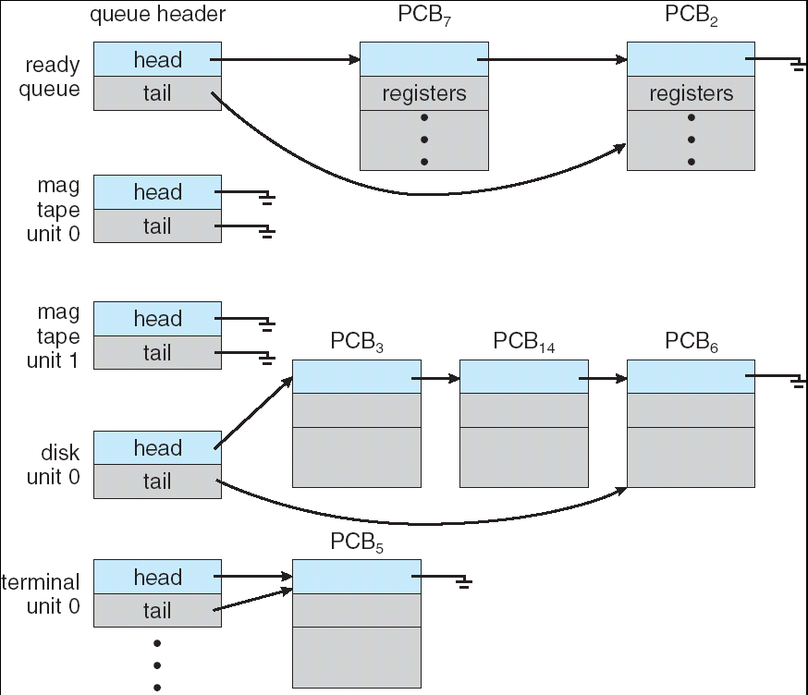

A common representation of process scheduling is a queuing diagram such as shown below:
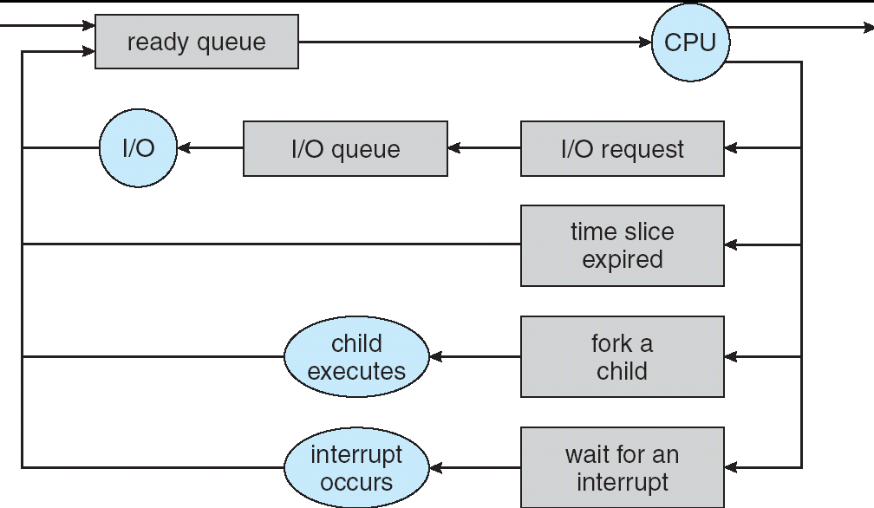

Representation of Process Scheduling
A new process is initially put in the ready queue. It waits in the ready queue until it is selected for execution(or dispatched). Once the process is assigned to the CPU and is executing, one of several events could occur:
- The process could issue an I/O request, and then be placed in an I/O queue.

- The process could create a new sub process and wait for its termination.

- The process could be removed forcibly from the CPU, as a result of an interrupt, and be put back in the ready queue.

In the first two cases, the process eventually switches from the waiting state to the ready state, and is then put back in the ready queue. A process continues this cycle until it terminates, at which time it is removed from all queues and has its PCB and resources deadlocked.

Schedulers: The OS by means of the appropriate Scheduler select the processes that migrate between the various scheduling queues, for scheduling purpose. There are different types of schedulers: The long-term scheduler(or job scheduler),the short-term scheduler(or CPU scheduler), and medium-term scheduler.
Long-term Scheduler: In a batch system, often more processes are submitted than can be executed immediately. These processes are submitted to a mass-storage device(typically a disk), where they are kept for later execution. The long-term scheduler or job scheduler selects processes from this pool and loads them into memory for execution. This scheduler controls the degree of multiprogramming—the number of processes in memory If the degree of multiprogramming is stable, then the average rate of process creation must be equal to the average departure rate of processes leaving the system. Thus, the scheduler may need to be evoked only when a process leaves the system and therefore, can afford to take more time to select a process for execution.
The long-term scheduler must make a careful selection of an I/O-bound or CPU-bound

process. It should select a good process mix of I/O-bound and CPU-bound processes.
On some systems such as timesharing system e.g. UNIX often have no long-term scheduler.
Short-term Scheduler: The short-term scheduler or CPU scheduler, selects from among the processes that are ready to execute, and allocates the CPU to one of them. The scheduler must select a new process for the CPU frequently. A process may execute for only a few milliseconds before waiting for an I/O request. Often, the short-term scheduler executes at least once every 100 milliseconds.
Medium-term scheduler: This scheduler is nothing but the short-term scheduler but only swapping scheme is used to improve the process mix(I/O-bound &CPU-bound).

It is mainly used in certain operating systems like time sharing.The key idea behind a medium term scheduler is that sometimes it can be advantageous to remove processes from memory and and at some later time the process can be reintroduced in the memory and its execution can be continued from where it left off. This is called swapping .The process are moved temporarily to an area in the hard disk called as swap space. The process is swapped out and later swapped in by the medium scheduler.

Context Switch: Switching the CPU to another process requires saving the state of the old process and loading the saved state for the new process. This task is known as a context switch. The context of a process is represented in the PCB of a process; it includes the value of the CPU registers, the process state, and memory management information. When a contexr switch occurs, the kernel saves the context of the old process in its PCB and loads the saved context of the new process scheduled to run. Context- switch time
is pure overhead, because the system does no useful work while switching. Its speed varies from machine to machine, depending on the memory speed, the number of register that must be copied, and the existence of the special instructions (such as a single instruction to load or store all registers).Some processors such as the Sun UltraSPARC provide multiple sets of registers, a context-switch simply includes changing the pointer to the current register set. Of course, if active processes exceed register sets, the system resorts to copying register data to and from memory. Also, the more complex the OS, the more work must be done during a context switch. Advanced memory-management technique may require extra data to be switched with each context.

Light weight processes:

Light weight process(LWP): A thread, sometimes called a lightweight process(LWP), is a basic unit of CPU utilization; it comprises a thread ID, a program counter, a register set, and a stack. It shares with other threads belonging to the same process its code section, data section, and other operating-system resources, such as open files and signals. A traditional( or heavyweight) process has a single thread of control. If the process has multiple threads of control, it can do more than one task at a time.

Single & multithreaded processes:

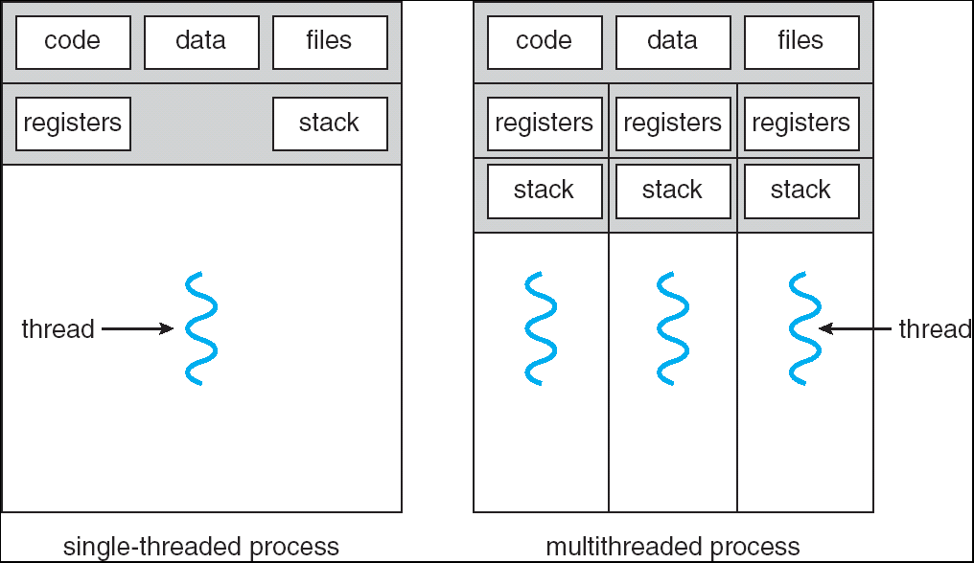

Single threaded processes: A traditional( or heavyweight) process has a single thread of control. E.g. if a process is running a word-processor program, a single thread of instruction is being executed. This single thread of control allows the process to perform only one task at one time. E.g. , the user could not simultaneously type in characters and run the spell checker within the same process.
Multithreaded processes: In certain situations a single application may be required to perform several tasks. E.g. , a web server accepts client requests for web pages, images, sound, and so forth. A busy web server may have several(perhaps hundreds) of clients concurrently accessing it. If the web server ran as a traditional single-threaded process, it would be able to service only one client at a time. The amount of time that a client might have to wait for its request to be serviced could be enormous. It is generally more efficient for one process that contains multiple threads to serve the same purpose. The server would create a separate thread that would listen for the client requests; when a request was made, rather than creating another process, it would create another thread to service the request.
The benefits of multithreaded programming have four major categories:
  - Responsiveness: Interactive application may allow a program to continue running even if part of it is blocked or is performing a lengthy operation, thereby increasing responsiveness to the user. For instance, a multithreaded wed browser could still allow user interaction in one thread while an image is being loaded in another thread.
  - Resource sharing: By default, thread shared the memory and the resources of the process to which they belong. The benefit of code sharing is that it allows an application to have several different threads of activity all within the same address space.
  - Economy: Threads share resources of the process to which they belong, it is more economical to create and context switch threads. It is much more time consuming to create and manage processes than threads.
  - Utilization of multiprocessor architectures: Multithreading on a multi-CPU machine increases concurrency. In a single processor architecture, the CPU generally moves between each thread so quickly as to create an illusion of parallelism, but in reality only one thread is running at a time.

User and Kernel Threads: Threads that are provided at the user level are called as user threads and by the kernel, called as kernel threads.
- User threads: They are supported above the kernel and are implemented by a thread library at the user level Library provides support for thread creation, scheduling, and management with no support from the kernel. All thread creation and scheduling are done in user space without the need for kernel intervention and therefore, fast to create and manage; but the drawback is that if the kernel is single threaded , then any user-level thread performing a blocking system call will cause the entire process to block, even if other threads are available to run within the application. User-thread libraries include POSIX Pthreads, Mach C-threads, and Solaris 2UI-threads.
- Kernel threads: They are supported directly by OS. The kernel performs thread creation, scheduling and management in kernel space. Since the thread management is performed by the OS, kernel threads are slower to create and manage than the user threads. However, since the kernel is managing the thread, if a thread performs a blocking system call, the kernel can schedule another thread in the application for execution. Also, in a multiprocessor environment, the kernel can schedule threads on different processors. Windows NT, Windows 2000, Solaris2, BeOS, and Tru64 UNIX-support kernel threads.

Multithreading Models: There are mainly three types of multithreading models are available for user and kernel threads.
- Many-to-One Model:
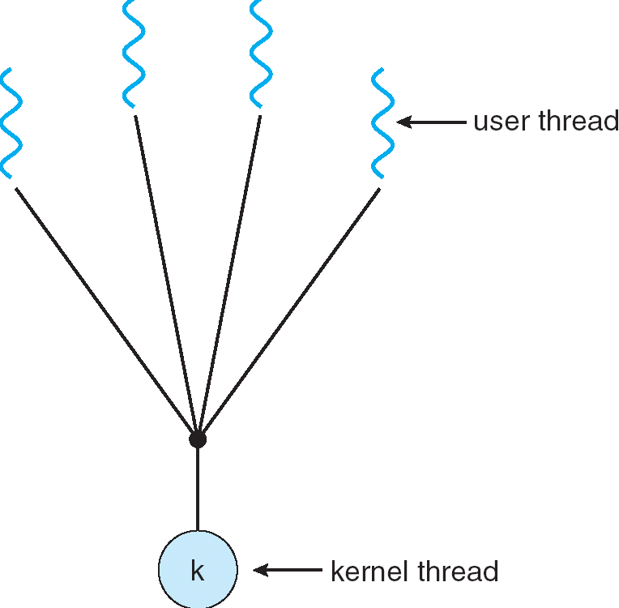

The many-to-one model maps many user-level threads to one kernel thread. Thread management is done in user space, so it is efficient, but the entire process will block if a thread makes a blocking system call. Because only one thread can access the kernel at a time, multiple threads are unable to run in parallel on multiprocessors. Green threads- a thread library available for solaris 2-uses this model. Os that do not support the kernel threads use this model for user level threads.

- One-to-One Model:
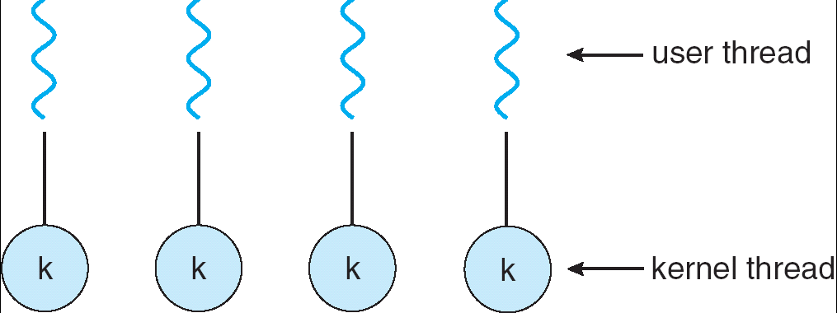

Maps each user thread to a kernel thread. Allows another thread to run when a thread makes a blocking system call. Also allows multiple threads to run in parallel on multiprocessors. Drawback is that creating a user thread requires creating the corresponding kernel thread. Because the overhead of creating kernel threads can burden the performance of an application, and therefore, restriction has to be made on creation of number of threads. Window NT, Windows 2000, and OS/2 implement this model.

- Many-to-Many Model:

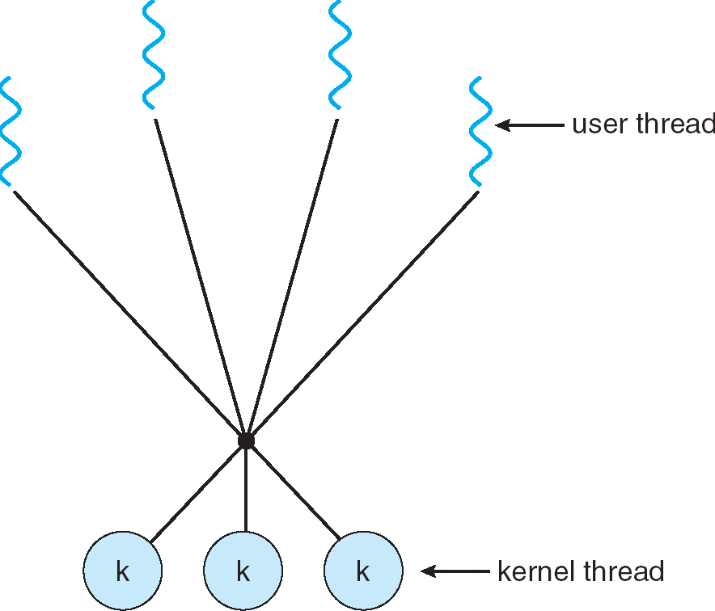
Multiplexes many user-level threads to smaller or equal number of kernel threads. The number of kernel threads may be specific to either a particular application or a particular machine( an application may be allocated more kernel threads on a multiprocessor than on a uniprocessed).

Model allows the developer to create as many user threads as he wishes, true concurrency is not gained because the kernel can schedule only one thread at a time, but the corresponding kernel threads can run in parallel on a multiprocessor. Also, when a thread performs a blocking system call, the kernel can schedule another thread for execution. Solaris 2, IRIX, HP-UX and TRU64 UNIX support this model.

Process synchronization

Concurrent access to shared data may result in data inconsistency.
Maintaining data consistency requires mechanisms to ensure the orderly execution of cooperating processes.

Consider the following solution for a bounded buffer producer –consumer problem , where we have producer process producing items on to a bounded buffer and the items are consumed by a consumer problem. A producer should stop producing items when the buffer becomes full and consumer should not consume an item when the buffer is empty.

Shared data
#define BUFFER_SIZE 10
typedef struct {
. . .
} item;
item buffer[BUFFER_SIZE];
int in = 0;
int out = 0;
int counter = 0;

Producer process code

item nextProduced;
while (1) {
while (counter == BUFFER_SIZE)
; /* do nothing */
buffer[in] = nextProduced;
in = (in + 1) % BUFFER_SIZE;
counter++;
}

Consumer process code

item nextConsumed;
while (1) {
while (counter == 0)
; /* do nothing */
nextConsumed = buffer[out];
out = (out + 1) % BUFFER_SIZE;
counter--;
}
The statements
counter++;
counter--;
must be performed atomically.

Atomic operation means an operation that completes in its entirety without interruption.
The statement “counter++” may be implemented in machine language as:
register1 = counter
register1 = register1 + 1
counter = register1
The statement “counter—” may be implemented as:
register2 = counter
register2 = register2 – 1
counter = register2

If both the producer and consumer attempt to update the buffer concurrently, the assembly language statements may get interleaved.

Interleaving depends upon how the producer and consumer processes are scheduled.
Assume counter is initially 5. One interleaving of statements is:
producer: register1 = counter (register1 = 5)
producer: register1 = register1 + 1 (register1 = 6)
consumer: register2 = counter (register2 = 5)
consumer: register2 = register2 – 1 (register2 = 4)
producer: counter = register1 (counter = 6)
consumer: counter = register2 (counter = 4)
The value of count may be either 4 or 6, where the correct result should be 5.

Race condition: The situation where several processes access – and manipulate shared data concurrently. The final value of the shared data depends upon which process finishes last.

To prevent race conditions, concurrent processes must be synchronized.

Critical Section Problem and its solutions:
Consider a system consisting of n processes { P0, P1,…..Pn-1}. Each process has a segment of code, called a critical section, in which the process may be changing common variables, updating a table, writing a file, and so on. The important feature of the system is that, when one process is executing in its critical section, no other process is to be allowed to execute in its critical section.
Thus, the execution of the critical section by the processes is mutually exclusive in time. The critical-section problem is to design a protocol that the processes can use to cooperate. Each process must request permission to enter its critical section. The section of code implementing this request is the entry section. The critical section may be followed by an exit section.. The remaining code is the remainder section.
General structure of a typical process Pi :

do {
entry section

critical section

exit section

remainder section

} while(1);

The entry section and exit section are enclosed in boxes to highlight these important segments of code.

A solution to the critical-section problem must satisfy the following three requirements:

- Mutual Exclusion: If process Pi is executing in its critical section, then no other processes can be executing in their critical sections.
- Progress: If no process is executing in its critical section and some processes wish to enter their critical sections, then only those processes that are not executing in their remainder section can participate in the decision on which will enter its critical section next, and this selection cannot be postponed indefinitely.
- Bounded Waiting: There exists a bound on the number of times that other processes are allowed to enter their critical sections after a process has made a request to enter its critical section and before that request is granted.
We assume that each process is executing at a nonzero speed. However, we can make no assumption concerning the relative speed of the n processes.
The solutions do not rely on any assumptions concerning the hardware instructions such as load, store, and test etc. or the number of processes that hardware supports.

Two-Process Solutions:
Algorithms that are applicable to only two processes at a time is called as two-process solutions. Consider the processes numbered as P0 and P1. For convenience, when presenting Pi, we use Pj to denote the other process; that is, j == 1 - i.

Algorithm 1: Let the processes share a common integer variable turn initialized to 0 (or 1).
If turn == 1, then process Pi is allowed to execute in its critical section. The structure of process Pi is shown below:
do {
while ( turn != i );

Critical section
turn = j;

Remainder section

} while (1);

This solution ensures that only one process at a time can be in its critical section. However, it does not satisfy the progress requirement, since it requires strict alternation of processes in the execution of the critical section For example, if turn == 0 and P1 is ready to enter its critical section , P1 cannot do so, even though P0 may be in its remainder section.

Algorithm 2:
The problem with algorithm 1 is that it does not retain sufficient information about the state of each process; it remembers only which process is allowed to enter its critical section. To remember this problem, we can replace the variable turn with the following array:

boolean flag[2];

The elements of the array are initialized to false. If flag[i] is true, this value indicates that Pi is ready to enter the critical section. The structure of process Pi is shown below:
do {
flag[i] = true;
while ( flag[j] );
In this algorithm, process P_{i} first sets flag[i] to be true , signaling that it is ready to enter its critical section. Then, P_{i}, checks to verify that process P_{j} is not also ready to enter its critical section. If P_{j} were ready, then P_{i} would wait until P_{j} had indicated that it no longer needed to be in the critical section (that is, until flag[j] was false). At this point, P_{i} would enter the critical section. On existing the critical section, P_{i}

would set flag[i] to be false, allowing the other process(if it is waiting) to enter its critical section.

Critical section
flag[i] = false;

Remainder section
} while (1);

In this solution, the mutual-exclusion requirement is satisfied, but the progress requirement is not met e.g. consider the following execution sequence:

T0: P0 sets flag[0] = true
T1: P1 sets flag[1] = true

Now P0 and P1 are looping forever in their respective while statements. To avoid this either their must be several processes executing concurrently, or where an interrupt(such as a timer interrupt) occurs immediately after step T0 is executed, and the CPU is switch from one process to another. Otherwise, we can use in a situation where it is possible for both processes to be in the critical section at the same time, violating the mutual-exclusion requirements.

Peterson’s Algorithm :
If we have a combination of Algorithms 1 and algorithm 2, we obtain a correct solution to the critical section problem, where all the following three requirements(properties) are met.
- Mutual exclusion is preserved.
- The progress requirement is satisfied.
- The bounded-waiting requirement is met.

The process share two variables:
boolean flag[2];
int turn;
Initially flag[0] = flag[1] = false, and the value of turn is immaterial(but either 0 or 1). The structure of process Pi is shown below:

do {
flag[i] = true;
turn =j;
while ( flag[j] && turn == j);

Critical section

flag[i] = false;

Remainder section

} while (1);
To prove property 1, we note that each Pi enters its critical section only if either
flag[j] = = false or turn == i. Also note that, if both processes can be executing in their critical sections at the same time, then flag[0] == flag[1] == true. These two observations imply that P0 and P1 could not have successfully executed their while statements at about the same time, since the value of turn can be either 0 or 1, but cannot be both. Hence, one of the processes—say Pj—must have successfully executed the while statement, whereas Pi had to execute at least one additional statement (“turn ==j”). However, since, at that time, flag[j] == true, and turn == j, and this condition will persist as long as Pj is in its critical section, the result follows: Mutual exclusion is preserved.
To prove properties 2 and 3, we note that a process Pi can be prevented from entering the critical section only if it is stuck in the while loop with the condition flag[j] == true and turn == j ; this loop is only one. If Pj is not ready to enter the critical section, then flag[j] = = false and Pi can enter its critical section. If Pj has set flag[j] to true and is also executing in its while statement, then either turn == i or turn == j. If turn == i, then Pi will enter the critical section. If turn == j, then Pj will enter the critical section. However, when once Pj exists its critical section, it will reset flag[j] to false, allowing Pi to enter critical section. If Pj resets flag[j] to true, it must also set turn to i. Thus since Pi does not change the value of the variable
Turn while executing the while statement, Pi will enter the critical section (progress) after at most one entry by Pj (bounded waiting).

Semaphores

To solve the critical section problem a synchronization tool called semaphore can be used.
A semaphore S is an integer variable that, apart from initialization, is accessed only through two standard atomic operations: wait and signal. These operations were originally termed P (for wait; from the Dutch proberen, to test ) and V(for signal; from verhogen, to increment). The classical definition of wait in pseudocode is.
wait (S) {
while (S ≤ 0); // no-op
S--;
}
The classical definitions of signal in pseudocode is

Signal (S) {
S++;
}
Modifications to the integer value of the semaphore in the wait and signal operations must be executed indivisibly. That is, when one process modifies the semaphore value, no other process can simultaneousely modify that same semaphore value. In addition, in the case of wait(S), the testing of the integer value of
S (S ≤ 0), and its possible modification (S--), must also be executed without interruption.

Usage: Semaphores can be used to deal with the n-process critical-section problem The n processes share a semaphore, mutex(mutual exclusion), initialized to 1. Each process Pi is organized as shown below: (mutual-exclusion implementation with semaphores)
do {
wait(mutex);

Critical section
signal(mutex);

Remainder section

}while(1);

We can also use semaphores to solve various synchronization problems. E.g., consider two concurrently running processes: P1 with a statement S1 and P2 with the statement S2. Suppose that we require that S2 be executed only after S1 has completed. We can implement this scheme readily by letting P1 and P2 share a common semaphore synch, initialized to 0, and by inserting the statements
S1;
signal (synch);
in process P1, and the statements
wait(synch);
S2;
in process P2. Because synch is initialized to 0, P2 will execute S2 only after P1 has invoked signal(synch), which is after S1.

Implementation
While a process is in its critical section, any other process that tries to enter the critical section must loop continuously in the entry code. This continual looping is clearly a problem in a real multiprogramming system , where a single CPU is shared among many processes. Busy waiting wastes CPU cycles that some other process might be able to use productively. This type of semaphore is also called a spinlock(because the process “spins” while waiting for the lock) . To overcome the need for busy waiting, we can modify the definition of the wait and signal semaphore operations. When a process executes the wait operation and finds that the semaphore value is not positive, it must wait. However, rather than busy waiting, the process can block itself. The block operation places a process into a waiting queue associated with the semaphore, and the state of the process is switched to the waiting state. Then, control is transferred to the CPU scheduler, which selects another process to execute.
A process that is blocked, waiting on a semaphore S, should be restarted when some other process executes a signal operation. The process is restarted by a wakeup operation, which changes the process from the waiting state to ready state. The process is then placed in the ready queue. (The CPU may or may not be switched from the running process to the newly ready process, depending on the CPU-scheduling algorithm.)
The implementation of semaphore using this definition under “C” struct is as follows:

typedef struct {
int value;
struct process *L;
} semaphore;

The wait semaphore operation can now be defined as

void wait (semaphore S) {
S.value--;
if (S.value < 0) {
add this process to S.L;
block( );
}
}

The signal semaphore operation can now be defined as

void signal (semaphore S) {
S.value++;
if (S.value <= 0) {
remove a process P from S.L;
wakeup (P);
}
}

Each semaphore has an integer value and a list of processes. When a process must wait on a semaphore, it is added to the list of processes. A signal operation removes one process from the list of waiting processes and awakens that process.
The block operation suspends the process that invokes it. The wakeup (P) operation resumes the execution of a blocked process P. These two operations are provided by OS as basic system calls.
Since the semaphores are executing automatically, no two processes can execute wait and signal operations on the same time. This can be solved as follows:

Semaphores are classified as binary semaphores and counting semaphores.
Binary Semaphores: binary semaphore is a semaphore with an integer value that can range only 0 and 1 and would be simpler to implement , depending upon the underlying hardware architecture.Counting semaphore takes any integer value.

Deadlock and Starvation:

Deadlock – two or more processes are waiting indefinitely for an event that can be caused by only one of the waiting processes.
Let S and Q be two semaphores initialized to 1
P0 P1

wait(S); wait(Q);
wait(Q); wait(S);
…. …..

signal(S); signal(Q);
signal(Q) signal(S);

Suppose that P0 executes wait(S), and then P1 executes wait(Q). When P0 executes wait(Q), it must wait until P1 executes signal (Q). Similarly, when P1 executes wait(S), it must wait until P0 executes signal(S). Since these signal operations cannot be executed, P0 and P1 are deadlocked.

Starvation – indefinite blocking. A process may never be removed from the semaphore queue in which it is suspended

Monitors
High-level synchronization construct that allows the safe sharing of an abstract data type among concurrent processes.

Syntax for Monitors:

monitor monitor-name
{
shared variable declarations

procedure body P1 (…) {
. . .
}
procedure body P2 (…) {
. . .
}
procedure body Pn (…) {
. . .
}
{
initialization code
}
}

- To allow a process to wait within the monitor, a condition variable must be declared, as
condition x, y;
- Condition variable can only be used with the operations wait and signal.
- The operation
x.wait();
means that the process invoking this operation is suspended until another process invokes
x.signal();
- The x.signal operation resumes exactly one suspended process. If no process is suspended, then the signal operation has no effect.
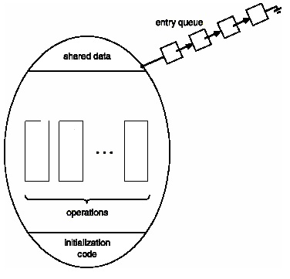

Monitor With Condition Variables

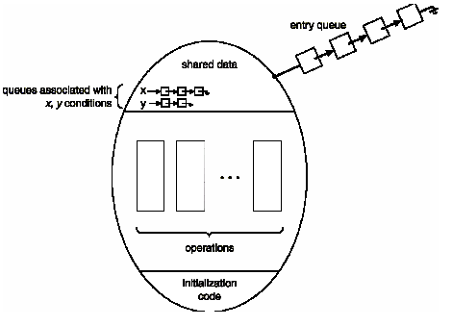

Message passing

Problem with monitors, and also with semaphores, is that they were designed for solving the mutual exclusion problem on one or more CPUs that all have access to a common memory. by putting the semaphores (or event counters) in the shared memory and protecting them with TSL instructions, we can avoid races. When we go to a distributed system consisting of multiple CPUs, each with its own private memory, connected by a local area network, these primitives become inapplicable. The conclusion is that semaphores are too low level and monitors are not usable except in a few programming languages. Furthermore, none of the primitives provide for information exchange between machines, and hence the method called MESSAGE PASSING is used.
This method of Interprocess communication uses two primitives SEND and RECEIVE, which, like semaphores and unlike monitors, are system calls rather than language constructs. As such, they can easily be put into library procedures, such as

send(destination, &message);

and

receive(source, &message);

the former sends a message to a given destination and the latter receives a message from a given source. If no message is available, the receiver could block until one arrives.

MUTUAL EXCLUSION: (Using Message Passing)

Now let us see how the produce-consumer problem can be solved with message passing and no shared memory. a solution is given in figure. We assume that all messages are the same size and that messages sent but not yet received are buffered automatically by the operating system. The consumer starts out by sending N empty messages to the producer. Whenever the producer has an item to give to the consumer, it takes an empty message and sends back a full one. In this way, the total number of messages in the system remains constant in time, so they can be stored in a given amount of memory.
If the producer works faster than the consumer, all the messages will end up full, waiting for the consumer; the producer will be blocked, waiting for an empty to come back. If the consumer works faster, then the reverse happens: all the messages will be empties waiting for the producer to fill them up; the consumer will be blocked, waiting for a full message.

For the producer-consumer problem, both the producer and consumer would create mailboxes (A mailbox is a place to buffer a certain number of messages, typically specified when the mailbox is created) large enough to hold messages. The producer would send messages containing data to the consumer’s mailbox, and the consumer would send empty messages to the producer’s mailbox. When mailboxes that have been sent to the destination process but have not yet been accepted.

Classical Problems of Process synchronization:
The number of different synchronization problems occurs. These problems are used for testing nearly every newly proposed synchronization scheme.
The Bounded-Buffer Problem: It is commonly used to illustrate the power of synchronization primitives. Consider the general structure of the scheme, without any particular implementation as follows:
Assume that the pool consists of n buffers, each capable of holding one item
The mutex semaphore provides mutual exclusion for accesses to the buffer pool and is initialized to the value 1.
The empty and full semaphores count the number of empty and full buffers, respectively.
The semaphore empty is initialized to the value n; the semaphore full is initialized to the value 0.

The code for the producer process is shown below:
do { …
produce an item in nextp
…
wait (empty);
wait (mutex)
…
add nextp to buffer
…
signal (mutex);
signal (full);
} while (1);

The code for the consumer process is shown below:
do {
wait (full);
wait (mutex)
…
remove an item from buffer to nextc
…
signal (mutex);
signal (empty);
…
consume the item in nextc
….
} while (1);

We can interpret this code as the producer producing full buffers for the consumer, or as the consumer producing empty buffers for the producer.

The Readers-Writers Problem: A data object (such as a file or record) is to be shared among several concurrent processes. Some of these processes may want only to read the content of the shared object, whereas others may want to update( that is, to read and write) the shared object. Referring to those processes that are interested in only reading are called as readers, and to the rest as writers. If two readers access the shared data object simultaneously, no adverse effects will result. However, if a writer and some other process(either a reader or a writer) access the shared object simultaneously, chaos may ensue. This synchronization problem is referred to as the readers-writers problem. The following priority based solutions are recommended:

a.) No reader will be kept waiting unless a writer has already obtained permission to use the shared object (i.e. no reader should wait for other readers to finish simply because a writer is waiting.)
Once a writer is ready, that writer performs its write as soon as possible.(i.e. if a writer is waiting to access the object, no new readers may start reading.)
A solution to either problem may result in starvation. In case “a” , writers may starve; and in case “b”, readers may starve.
For the starvation free readers-writers problem consider the following data structures:

semaphore mutex , wrt ;
int readcount ;
The semaphore mutex and wrt are initialized to 1; readcount is initialized to 0. The semaphore wrt is common to both the reader and writer processes. The mutex semaphore is used to ensure mutual exclusion when the variable readcount is updated. The readcount variable keeps track of how many processes are currently reading the object. The semaphore wrt functions as a mutual-exclusion semaphore for writers. It is also used by the first or last reader that enters or exits the critical section. It is not used by readers who enter or exit while other readers are in their critical sections

The code for a writer process is shown below:

wait (wrt) ;
…
writing is performed
…
signal (wrt);

The code for a reader process is shown below:

wait (mutex) ;
readcount++;
if (readcount == 1)
wait (wrt) ;
signal (mutex) ;
….
Reading is performed
…
wait (mutex) ;
readcount--;
if (readcount == 0)
signal (wrt) ;
signal (mutex);

The Dining-Philosophers Problem: Consider five philosophers who spend their lives thinking and eating. The philosophers share a common circular table surrounded by five chairs, each belongs to one philosopher In the center of the table is a bowl of rice, and the table is laid with five single chopsticks as shown in the figure.

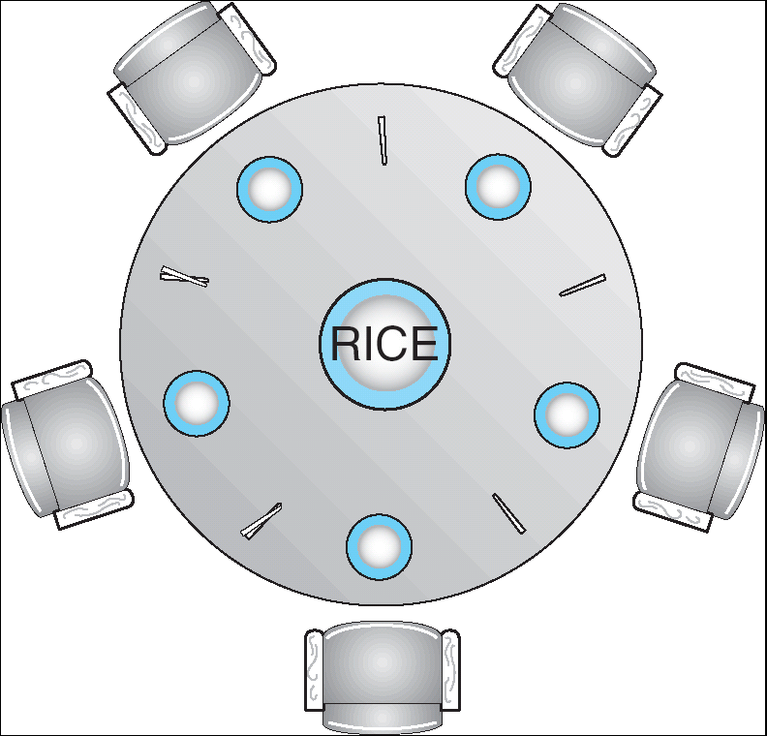

When a philosopher thinks, she does not interact with her colleagues. From time to time, a philosopher gets hungry and tries to pick up the two chopsticks that are closest to her( the chopsticks that are between her and her left and right neighbors). A philosopher may pick up only one chopstick at a time. Obviously, she cannot pick up a chopstick that is already in the hand of a neither. When a hungry philosopher has both her chopsticks at the same time, she eats without releasing her chopsticks. When she is finished eating, she puts down both of her chopsticks and starts thinking again.
The dining-philosophers problem is considered a classic synchronization problem and is a simple representation of the need to allocate several resources among several processes in a deadlock and starvation free manner.

Solution for dining –philosopher problem by using Semaphore:
Represent each chopstick by a semaphore. A philosopher tries to grab the chopstick by executing a wait operation on that semaphore; she releases her chopsticks by executing the signal operation on the appropriate semaphores. Thus, the shared data are:
semaphore chopstick [5];
where all the elements of chopstick are initialized to 1. The structure of philosopher i is shown below:

The structure of Philosopher i:
do {
wait(chopstick[i])
wait(chopstick[(i+1) % 5])
…
eat
…
signal(chopstick[i]);
signal(chopstick[(i+1) % 5]);
…
think
…
} while (1);

This solution guarantees that no two neighbors are eating simultaneously but it has the possibility of creating a deadlock. Suppose that all five philosophers become hungry simultaneously, and each grabs her left chopstick. All elements of chopstick will now be equal to 0. When each philosopher tries to grab her right chopstick, she will be delayed for ever.

2. Solution for dining –philosopher problem by using monitor:

Data structure: enum {thinking, hungry, eating} state[5];
Philosopher i can set the variable state [i] = eating only if her two neighbors are not eating:
(state [(i + 4) % 5] != eating) and (state [(i + 1) % 5] != eating).

We also need to declare- condition self [5];
where philosopher i can delay herself when she is hungry, but is unable to obtain the chopsticks she needs. The distribution of the chopsticks is controlled by the monitor dp, whose definition is shown below.
Each philosopher, before starting to eat, must invoke the operation pickup . This may result in the suspension of the philosopher process. After the successful completion of the operation, the philosopher may eat. Following this, the philosopher invokes the putdown operation, and may start to think. Thus, philosopher i must invoke operations pickup and putdown in the following sequence:

dp.pickup(i);
…
eat
…
dp.putdpwn(i);
monitor dp
{
enum {thinking, hungry, eating} state[5];
condition self[5];
void pickup(int i)
void putdown(int i)
void test(int i)
void init() {
for (int i = 0; i < 5; i++)
state[i] = thinking;
}
}

void pickup(int i) {
state[i] = hungry;
test(i);
if (state[i] != eating)
self[i].wait();
}

void putdown(int i) {
state[i] = thinking;
// test left and right neighbors
test((i+4) % 5);
test((i+1) % 5);
}

void test(int i) {
if ( (state[(I + 4) % 5] != eating) &&
(state[i] == hungry) &&
(state[(i + 1) % 5] != eating)) {
state[i] = eating;
self[i].signal();
}
}
void init() {

for (int i = 0; i < 5; i++)
state[i] = thinking;
}
}

It is easy to show that this solution ensures that no two neighbors are eating simultaneously, and that no deadlock occur.

CPU Scheduling

Basic concepts: CPU scheduling is the basis of Multiprogrammed OS. The objective of multiprogramming is to have some process running at all times, in order to maximize CPU utilization. Several processes are kept in memory at one time. When one process has to wait, typically for the completion of some I/O request, the OS takes the CPU away from that process and gives the CPU to another process. This pattern continues.
CPU- I/O burst cycle:
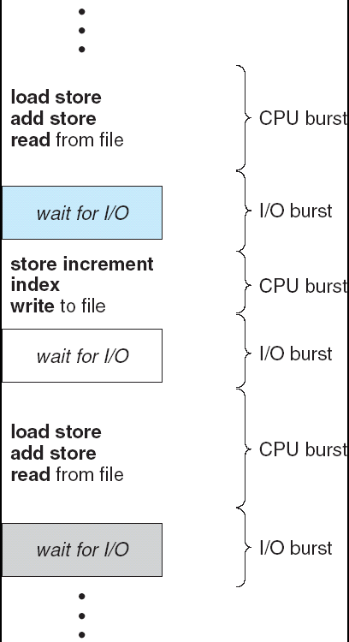
The success of CPU scheduling depends upon the CPU-I/O Burst Cycle Process execution consists of a cycle of CPU execution and I/O wait. Process alternate between these two states. Process execution begins a CPU burst. That is followed by an I/O burst, then another CPU burst, then another I/O burst, and so on. Eventually, the last CPU burst will end with a system request to terminate execution, rather than with another I/O burst.
The duration of these CPU burst are measured in terms of the exponenential or hyperexpontial curve. A CPU-bound program might have a few very long CPU bursts where as an I/O-bound program would typically have many very short CPU burst.

CPU scheduler: Whenever the CPU becomes idle; the OS must select one of the processes in the ready queue to be executed. The short-term scheduler or CPU scheduler carries out the selection process. The scheduler selects from among the processes in memory that are ready to execute, and allocates the CPU to one of them.
A ready queue may be implemented as a FIFO queue, a priority queue, a tree, or simply an unordered linked list. Conceptually, however, all the processes in the ready queue are lined up waiting for a chance to run on the CPU. The records in the queues are generally process control blocks(PCBs) of the processes.

Preemptive Scheduling: Scheduling is carried out under the following four circumstances:
- When a process switches from the running state to the waiting state e.g. I/O request, invocation of wait for termination of one of the child processes.
- When a process switches from the running state to the ready state e. g when an interrupt occurs.
- When a process switches from the waiting state to the ready state e.g. completion of I/O.
- when a process terminates.

When scheduling takes place only under circumstances 1 and 4, we say the scheduling scheme is nonpreemptive; otherwise the scheduling scheme is preemptive.

Preemptive scheduling requires a special hardware such as timer, special mechanism to cooperate access to shared data e.g. consider the two processes sharing data. One may be in the midst of updating the data when it is preempted and the second process is run. The second process may try to read the data, which are currently in an inconsistence state.
To avoid the problems created during preemption the kernel of OS must be specially designed. E.g. during the processing of a system call, the kernel may be busy with an activity on behalf of a process. Such activities may involve changing important kernel data(for instance, I/O queues. What happens if the process is preempted in or modify the same structure? Chaos could result. Some Operating Systems(most versions of UNIX), deal with this problem by waiting either for a system call to complete or for an I/O block to take place, before doing a context switch. Also for improving the efficiency of the CPU, the interrupt state changes must be minimize and fine-grained locking maximized for preemptive scheduling.

Dispatcher: The dispatcher is the module that gives control of the CPU to the process selected by the short-term scheduler. This function involves:
- Switching context.
- Switching to user mode.
- Jumping to the proper location in the user program
The dispatch latency should be small(that is the time taken by the dispatcher to stop one process and start another running).

Scheduling criteria: Different CPU-scheduling algorithms are available depending upon the class of processes. These scheduling algorithms are mainly based on the following criteria.
- CPU utilization: To keep CPU busy, utilization may range from 0 to 100 percent. In a real system, it should range from 40%(for a lightly loaded system) to 90%(for a heavily used system).
- Throughput: One measure of work done by CPU is the number of processes completed per time unit, called throughput. For short transaction, throughput might be 10 processes per second and for long processes rate may be 1 process per hour.
- Turnaround time: The interval from the time of submission of process to the time of completion of process is the turnaround time. This time is the sum of the periods spent waiting to get into memory, waiting in the ready queue, executing on the CPU and doing I/O.
- Waiting time: The CPU-scheduling affects only the amount of time that a process spends waiting in the ready queue. Waiting time is the sum of the periods spent waiting in the ready queue.
- Response time: The time from the submission of a request until the first response is produced. This measure, called response time, is the amount of time it takes to start responding, but not the time that it takes to output that response. The turnaround time is generally limited by the speed of the output device.

Generally the users require to maximize CPU utilization and throughput, and to minimize turnaround time, waiting time, and response time. In most cases, we optimize the average measure. However in some circumstances we want to optimize the minimum or maximum values, rather than the average. Minimizing the variance in the response time is more important than minimizing the average response time. A system with the reasonable and predictable response time may be considered more desirable than a system that is faster on the average, but is highly variable.

Scheduling Algorithms: The following CPU-scheduling algorithms are available:
- First-Come, First-Served Scheduling.
- Shorted-job-First Scheduling.
- Priority Scheduling.
- Round-Robin Scheduling.

1.First-Come, First-Served Scheduling (FCFS): The process that requests the CPU first is allocated the CPU first. FIFO(First In First Out)queue is implemented. When a process enters the ready queue, its PCB is linked onto the tail of the queue. When the CPU is free, it is allocated to the process at the head of the queue. The running process is then removed from the queue. The code for FCFS scheduling is simple to write and understand
The average waiting time is long and depends upon the order in which the processes arrive. Consider the following set of processes that arrive at time 0, with the length of the CPU-burst time given in milliseconds:

Process | Burst Time
P₁ | 24
P₂ | 3
P₃ | 3
If the processes arrive in the order P_{1,} P_{2,} P_{3,} and are served in FCFS order, we get the result shown in the following Gantt chart.
P₁
P₂
P₃
24
27
30
0

Waiting time for P1 = 0; P2 = 24; P3 = 27
Average waiting time: (0 + 24 + 27)/3 = 17
Suppose that the processes arrive in the order
P₂ , P₃ , P₁
The Gantt chart for the schedule is:
Waiting time for P₁ = 6; P₂ = 0; P₃ = 3
Average waiting time: (6 + 0 + 3)/3 = 3
Much better than previous case
Convoy effect short process behind long process

2. Shortest-Job-First Scheduling(SJF): When the CPU is available, it is assigned to the process that has the smallest next CPU burst. If two processes have the same length next CPU burst, FCFS scheduling is used to break the tie. Two schemes:
nonpreemptive – once CPU given to the process it cannot be preempted until completes its CPU burst preemptive – if a new process arrives with CPU burst length less than remaining time of current executing process, preempt. This scheme is know as the
Shortest-Remaining-Time-First (SRTF)
SJF is optimal – gives minimum average waiting time for a given set of processes

Example of Non-Preemptive SJF

Process | Arrival Time | Burst Time
P1 | 0.0 | 7
P2 | 2.0 | 4
P3 | 4.0 | 1
P4 | 5.0 | 4

SJF (non-preemptive)
Average waiting time = {(0 + (8-2) + (7-4) + (12-5)}/4 = (0 + 6 + 3 + 7)/4 = 4

Example of Preemptive SJF(Shortest Remaining Time First)

Process | Arrival Time | Burst Time
P1 | 0.0 | 7
P2 | 2.0 | 4
P3 | 4.0 | 1
P4 | 5.0 | 4

SJF (preemptive)

Average waiting time = {(11-2) + (5-4) + (4-4) + (7-5)}/4 = (9 + 1 + 0 +2)/4 = 3

3. Priority Scheduling: Priorities are generally some fixed range of numbers, such as 0 to 8, or 0 to 456 etc. However, there is no general agreement on whether 0 is the highest or lowest priority. Consider the following set of processes P₁, P₂,…..,P₅ arrived at time 0, with the length of the CPU-burst time in milliseconds;

Process | Burst Time | Priority
P1 | 10 | 3
P2 | 1 | 1
P3 | 2 | 4
P4 | 1 | 5
P5 | 5 | 2

Using priority scheduling we would schedule these processes according to the following Gantt chart:

P₂P₅P₁ P₃P₄

0 1 616 1819

The average waiting time = (6 + 0 +16 +18 + 1) /5 = 8.2 milliseconds.
Internally defined priorities use some measurable quantities to compute the priority of a process. e.g. time limits, memory requirements, number of open files, and the ratio of average I/O burst to average CPU burst have been used in computing priorities.
External priorities are set by criteria that are external to the OS., such as the importance of the process, the type and the amount of funds being paid for computer use and other factors that are considered by the organization.
Priority Scheduling can be either preemptive or non preemptive. A Preemptive priority scheduling algorithm will preempt the CPU if the priority of the newly arrived process is higher than the priority of the currently running process. A Non Preemptive priority scheduling algorithm will simply put the new process at the head of the ready queue.
A major problem with the priority scheduling algorithms is indefinite blocking (or Starvation). A process that is ready to run but lacking the CPU can be considered blocked—waiting for the CPU. In a heavily loaded system, a steady stream of higher-priority processes can prevent a low-priority process from ever getting the CPU(waiting indefinitely).
A solution to the problem of indefinite blockage of low-priority processes is aging. Aging is a technique of gradually increasing the priority of processes that wait in the system for a long time

4. Round-Robin Scheduling(RR): This algorithm is designed for time sharing systems. Similar to FCFS scheduling except the preemption is added to switch between processes. A small unit of time called a time quantum( or time slice), generally from 10 to 100 milliseconds is used. The ready queue is treated as a circular queue and is used as a FIFO queue of processes
New processes are added to the tail of the ready queue The CPU scheduler picks up the first process from the ready queue, sets a timer to interrupt after 1 time quantum, and dispatches the process.
One of the two things will happen. The process may have a CPU burst of less than 1 time quantum. In this case, the process itself will release the CPU voluntarily. The scheduler will then proceed to the next process in the ready queue. Otherwise, if the CPU burst of the currently running process is longer than 1 time quantum, the timer will go off and will cause an interrupt to OS. A context switch will be executed, and the process will be put at the tail of the ready queue. The CPU scheduler will then select the next process in the ready queue.
Consider the following set of processes P₁, P₂,…..,P₅ arrived at time 0, with the length of the CPU-burst time in milliseconds;

Process | Burst Time
P1 | 24
P2 | 3
P3 | 3

If we use a time quantum of 4 milliseconds, then process P₁ gets the first 4 milliseconds. Since it requires another 20 milliseconds, it is preempted after the first time quantum, and the CPU is given to the next process in the queue, process P₂ . Since process P₂ does not need 4 milliseconds, it quits before its time quantum expires. The CPU is then given to the next, process P_{3.} Once each process has received 1 time quantum, the CPU is returned to process P₁ for an additional time quantum. The resulting RR schedule is:
P₁ P₂ P₃ P₁ P₁ P₁ P₁ P₁
0 4 7 10 14 18 22 26 30

The average waiting time is = 0 + 4 + 7 + 6 = 17/3 = 5.66 milliseconds.
The performance of the RR algorithm depends heavily on the size of the time quantum.
If the time quantum is very large(infinite), the RR policy is the same as the FCFS policy. If the time quantum is very small(say 1 millisecond), the RR approach is called processor sharing. The smaller time quantum increases context switches as shown in the figure.

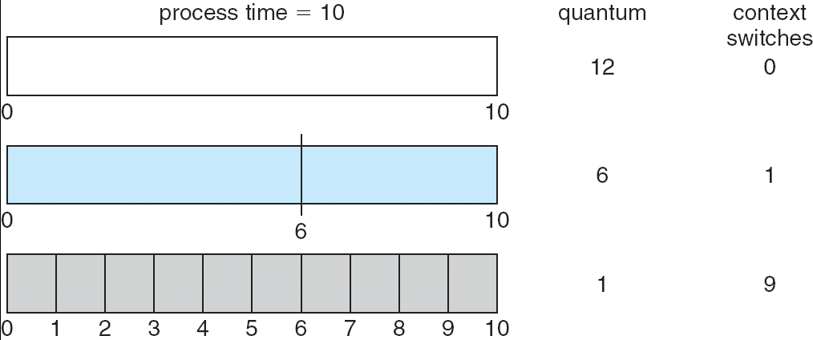

Turn around time also depends on the size of the time quantum As we can see from the figure, the average turnaround time of a set of processes does not necessarily improve as the time quantum size increases. In general, the average turnaround time can be improved if most processes finish their next CPU burst in a single time quantum.
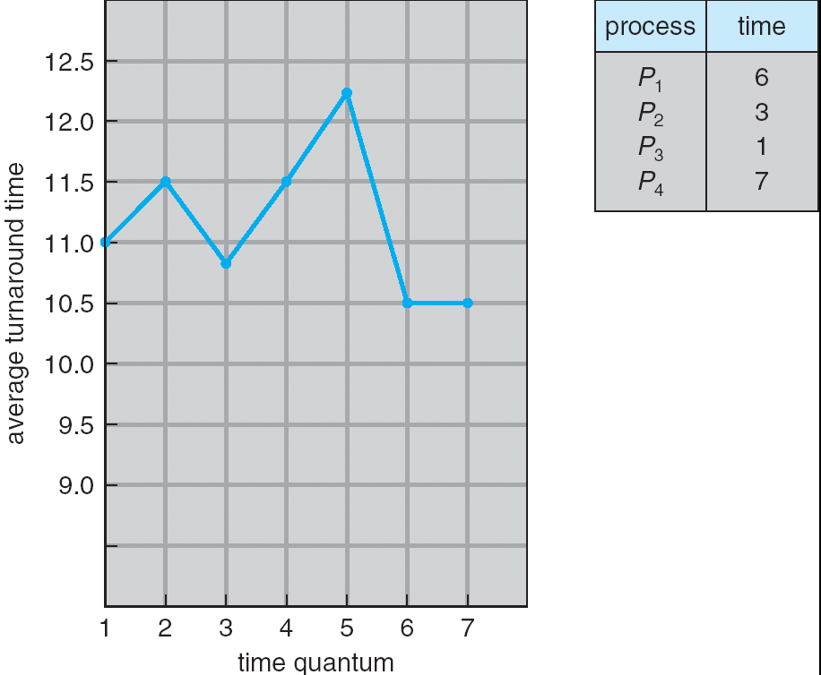

Multilevel Queue

- Ready queue is partitioned into separate queues:
  - foreground (interactive)
  - background (batch)
  - Each queue has its own scheduling algorithm:
  - foreground – RR
  - background – FCFS
  - Scheduling must be done between the queues:
  - Fixed priority scheduling; (i.e., serve all from foreground then from background). Possibility of starvation.
  - Time slice – each queue gets a certain amount of CPU time which it can schedule amongst its processes; i.e., 80% to foreground in RR
  - 20% to background in FCFS
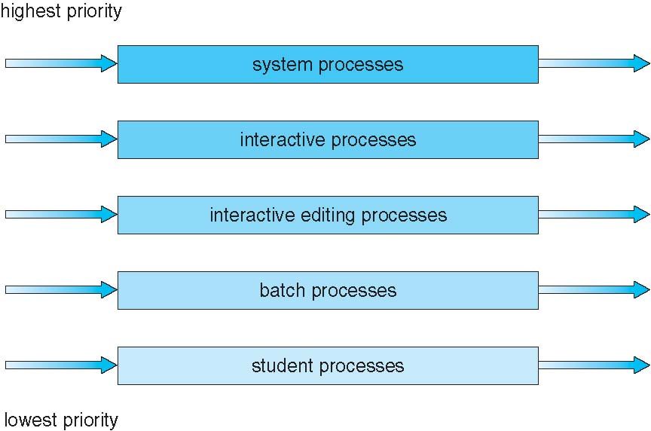

Multilevel Feedback Queue

- A process can move between the various queues; aging can be implemented this way.
- Multilevel-feedback-queue scheduler defined by the following parameters:
- number of queues
- scheduling algorithms for each queue
- method used to determine when to upgrade a process
- method used to determine when to demote a process
- method used to determine which queue a process will enter when that process needs service

Example of Multilevel Feedback Queue

- Three queues:
  - Q₀ – RR with time quantum 8 milliseconds
  - Q₁ – RR time quantum 16 milliseconds
  - Q₂ – FCFS
- Scheduling
  - A new job enters queue Q₀ which is served FCFS. When it gains CPU, job receives 8 milliseconds. If it does not finish in 8 milliseconds, job is moved to queue Q₁.
  - At Q₁ job is again served FCFS and receives 16 additional milliseconds. If it still does not complete, it is preempted and moved to queue Q₂

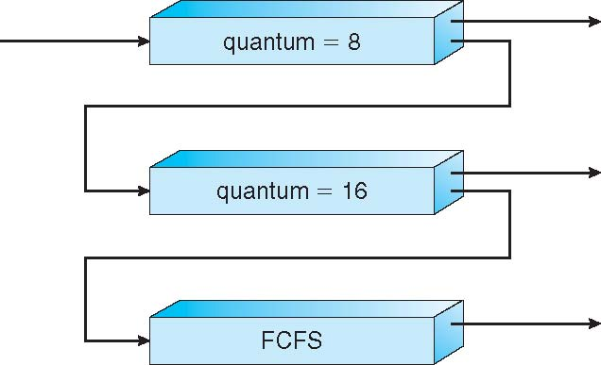

Thread Scheduling

- Distinction between user-level and kernel-level threads
- Many-to-one and many-to-many models, thread library schedules user-level threads to run on LWP
  - Known as process-contention scope (PCS) since scheduling competition is within the process
- Kernel thread scheduled onto available CPU is system-contention scope
(SCS) – competition among all threads in system

CONCURRENCY: DEADLOCK AND STARVATION

DEADLOCK

If two processes ask for a certain resource, which is held by the other process, there by letting neither of the process to move ahead this situation can be termed as a deadlock.

R1
R2
P2
P1
Request Owns

Owns Request

Here P1 owns R2 and request for R1, which is owned by P2, and vice-versa holds. i.e. deadlock takes place.

Resources: -

There are four classifications for resource type.

- Preemptable: - A Preemptable resource is one that can be taken away from the process owning it with no ill effects. Memory is an example of a Preemptable resource.

- Non-Preemptable: - A Non-Preemptable resource in contrast is one that cannot be taken away from its current owner without causing the computation to fail. Printers are not preemptable.

- Reusable: - A reusable resource is one that can be safely used by only one process at a time and is not depleted by that use. Processes obtain resource units that they later release for reuse by other processes. Examples of reusable resources include processor, I/O channels, main and secondary memory, devices, and data structures such as files, databases, and semaphores.

- Consumable: - A consumable resource is one that can be created and destroyed. Typically, there is no limit on the number of consumable resources of a particular type. An unblocked producing process may release any number of such resources. When a resource is acquired by a process, the resource ceases to exist. Examples of consumable resources are interrupts, signal messages, and information in I/O buffers.

An example of deadlock involving consumable resources, consider the following pair of processes: -

P1 P2
••• •••
Receive (P2, X); Receive (P1, Q);
••• •••
Send (P2, N); Send (P1, R)

Deadlock occurs if the Receive is blocking. Such errors may be quite subtle and difficult to detect. Further more, it may take a rare combination of events to cause the deadlock; thus a program could be in use for a considerable period, even years. Before the problem become evident.

From the above understanding we can firmly define deadlock as a set of processes is deadlocked if each process in the set is waiting for an event that only another process in the set can cause.
Deadlock Problem
In general set of blocked processes each holding a resource and waiting to acquire a resource held by another process in the set.
Example
System has 2 tape drives.
P1 and P2 each hold one tape drive and each needs another one.
Example
F semaphores A and B, initialized to 1
P0 P1
wait (A); wait(B)
wait (B); wait(A)

Bridge Crossing Example
- Traffic only in one direction.
- Each section of a bridge can be viewed as a resource.
- If a deadlock occurs, it can be resolved if one car backs
up (preempt resources and rollback).
- Several cars may have to be backed up if a deadlock
occurs.Starvation is possible.

Resource−Allocation Graph(RAG)

- Deadlock can be described through a resource allocation
graph.
- The RAG consists of a set of vertices P={P1,P2 ,…,Pn} of
processes and R={R1,R2,…,Rm} of resources.
- A directed edge from a processes to a resource, Pi->Rj, implies
that Pi has requested Rj.
- A directed edge from a resource to a process, Rj->Pi, implies
that Rj has been allocated by Pi.
- If the graph has no cycles, deadlock cannot exist. If the graph
has a cycle, deadlock may exist.

Notations for the graph is as follows

Basic Facts
- If graph contains no cycles Þ no deadlock.
- If graph contains a cycle Þ
- if only one instance per resource type, then deadlock.
- if several instances per resource type, possibility of
deadlock.

Condition For Deadlock: -

Four conditions must hold for there to be a deadlock: -

- Mutual exclusion condition. Each resource is either currently assigned to exactly one process or is available.

- Hold and wait condition. Processes currently holding resources granted earlier can request new resources.

- No preemption condition. Resources previously granted cannot be forcibly taken away from a process. They must be explicitly released by the process holding them.

- Circular wait condition. There must be a circular chain of two or more processes, each of which is waiting for a resource held by the next member of the chain.

All four of these conditions must be present for a present for a deadlock to occur. If one of them is absent, no deadlock is possible.

Methods for Handling Deadlocks
1 Ensure deadlocks never occur.
a. Deadlock prevention-make sure one of the characteristics never hold, or
b. Deadlock avoidance-requires more information about each process, allocate
resources in such a way that deadlock doesn’t occur.
2 Discover deadlocks and recover the system. Two parts:
a. Detection and
b. Recovery
both are necessary.
3 Ignore deadlocks. Ex: may start with a small group in a deadlock and then grow. The system will be unusable and have to be restarted.

1 a) Deadlock Prevention
- Mutual Exclusion : hard with some resources that cannot be shared,
for ex: CPU and printer.
- No Preemption: two variants:
a.If P will have to wait, deallocate all its resources and wait for all at a time.
b.If allocated to someone waiting, steal the resource! Else, wait (and you risk being stolen from).
OK for CPU, memory, etc. but not for printer, tape drive, etc.
- Circular Wait:
a. Impose a total ordering of all resource types (<)
b. Allocate resources in increasing order; several instances of the same resource type is allocated at the same time.
- Hold and Wait: two variants:
a. Allow process to request resources only when the process has none.
b. Allocate all before process starts.
Low resource utilization; starvation possible.

Mutual Exclusion

The first of the four conditions listed above cannot be disallowed. If access to a resource requires mutual exclusion, then mutual exclusion must be supported by the operating system. Some resources, such as files, may allow multiple accesses for reads, but only exclusive access for writes. Even in this case, deadlock can occur if more than one process requires write permission.

Hold and Wait

The hold-and-wait condition can be prevented by requiring that a process request all its required resources at one time blocking the process until all requests can be granted simultaneously. this approach is insufficient in two ways. First, a process may be held up for a long time. Second, resources allocated to a process may remain unused for a considerable period, during which time they are denied to other processes.

No Preemption

The Non-preemption condition can be prevented in several ways. First, if a process holding certain resources is denied a further request, that process must release its original resources and if necessary request them again together with the additional resource. Alternatively, if a process requests a resource that is currently held by an other process, the operating system may preempt the second process and require it to release its resources. This latter scheme would prevent deadlock only if no two processes processed the same priority.

This approach is practical only when applied to resources whose state can be easily saved and restored later, as is the case with a processor.
Circular Wait

The circular-wait condition can be prevented by defining a linear ordering of resource types. If a process has been allocated resources of type R, then it may subsequently request only those resources of types following R in the ordering.

Resource R1 precedes R1 in the ordering if i < j. now suppose that two processes, A and B, are deadlocked because A has acquired R1 and requested R1, and B has required R1 and requested R1, this condition is impossible because it implies i < j and j < i.

1 b) Deadlock Avoidance

a. If the OS knows beforehand what recources and what
order the process wants to allocate , the OS can order the requests so that deadlock does
not occur.
b.It is enough to know the maximum number of each resource type the process will need.
c. Requires that the system keep some more info in each PCB.

Idea: keep a Safe State of the system, avoid circular wait.
Safe State: If one can give each process its maximum number of resources (in some order) and keep the safe state.Such an order is called a Safe Sequence.
Ex: <P1,P2,P3>:Pi can get max resources from free resources plus from Pj, where j<i.
If no safe sequence exists: we are in an Unsafe State, which can lead to deadlock.
Basic Facts
If a system is in safe state then no deadlocks.
If a system is in unsafe state then possibility of deadlock.
Deadlock Avoidance will ensure that a system will never enter an unsafe state.

Deadlock Avoidance is carried out using Resource graph Algorithm for resources with single instance and using Banker’s Algorithm for resources with multiple instances.
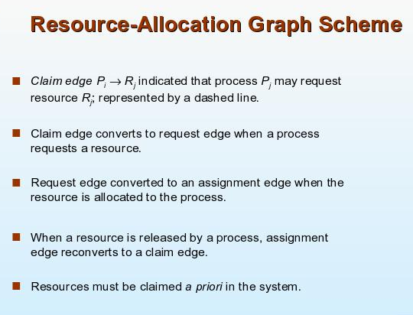
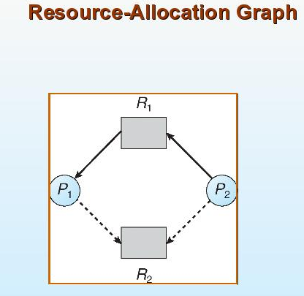
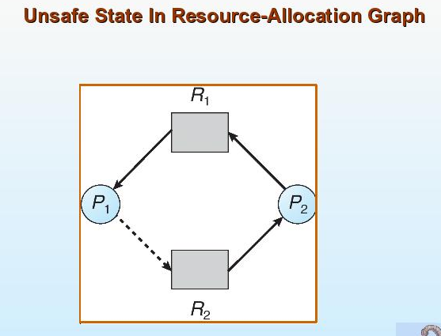

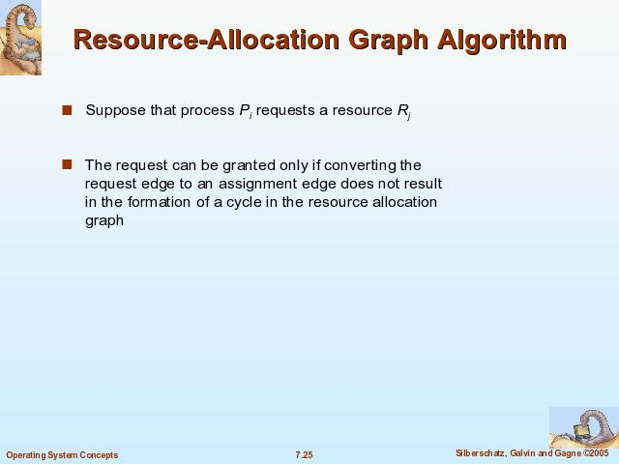

Banker.s Algorithm

Multiple instances.
Each process must a priori claim maximum use.
When a process requests a resource it may have to wait.
When a process gets all its resources it must return them in a finite amount of time.

Data Structures for the Banker.s Algorithm

Available: Vector of length m. If Available [j] = k, there are
k instances of resource type Rj available.
Max: n x m matrix. If Max [i,j] = k, then process Pi may
request at most k instances of resource type Rj.
Allocation: n x m matrix. If Allocation[i,j] = k, then Pi is
currently allocated k instances of Rj.
Need: n x m matrix. If Need[i,j] = k, then Pi may need k
more instances of Rj to complete its task.
Need [i,j] = Max[i,j] . Allocation [i,j].
Let n = number of processes, and m = number of resource types.

Safety Algorithm
1. Let Work and Finish be vectors of length m and n, respectively.
Initialize:
Work := Available
Finish [i] := false for i − 1,2, ., n.
2. Find and i such that both:
(a) Finish [i] = false
(b) Needi £ Work
If no such i exists, go to step 4.
3. Work := Work + Allocationi
Finish[i] := true
go to step 2.
4. If Finish [i] == true for all i, then the system is in a safe state.
May require an order of m x n2 operations to decide whether a
state is safe.

Resource−Request Algorithm for Process Pi
Requesti = request vector for process Pi.
If Requesti [j] = k then process Pi wants k instances of resource
type Rj.
1. If Requesti £ Needi go to step 2. Otherwise, raise error condition,
since process has exceeded its maximum claim.
2. If Requesti £ Available, go to step 3. Otherwise Pi must wait,
since resources are not available.
3. Pretend to allocate requested resources to Pi by modifying the
state as follows:
Available := Available = Requesti;
Allocationi := Allocationi + Requesti;
Needi := Needi . − Requesti;;
. If safe Þ the resources are allocated to Pi.
. If unsafe Þ Pi must wait, and the old resource−allocation state
is restored.

Recovery from Deadlock: Process Termination

Automatic recovery: two ways:
- Abort deadlocked processes.
- All deadlocked (easy, but costly)
- Abort one process at a time until the deadlock cycle is eliminated. (costly)
(hard to decide what order to kill processes)
- Preempt recources: deallocate resources and give to other processes until deadlock solved
Hard to choose victim
What should we do with the victim? -Rollback or kill the process
Starvation should be avoided − not the same victim each time.
In which order should we abort?
Priority of the process.
How long process has computed, and how much longer to
completion.
Resources the process has used.
Resources process needs to complete.
How many processes will need to be terminated.
Is process interactive or batch

